




City of Victoria

2017-2018
One-Year
Action Plan

August 2017

Acknowledgements
CITY COUNCIL
Paul Polasek, Mayor
Jeff Bauknight, District 3, Mayor Pro-Tem
Rafael De La Garza III, District 1
Josephine Soliz, District 2
Jan Scott, District 4
Dr. Andrew Young, District 5
Tom Halepaska, District 6

CITY ADMINISTRATION
Charmelle Garrett, City Manager
John Kaminski, Assistant City Manager
Julie Fulgham, Director Development Services

DEPARTMENT OF DEVELOPMENT SERVICES
Darlah K. Sims, Community Development Coordinator
William Charles, Planner

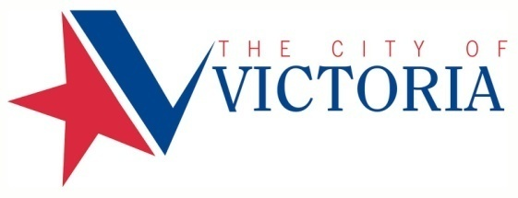

DEPARTMENT OF DEVELOPMENT SERVICES
700 Main Center • Suite 129
P.O. Box 1758
Victoria, Texas 77902
Phone: 361.485.3360
Fax: 361.485.3364
www.victoriatx.org

Contents
Acknowledgements 2
Executive Program Summary 4
AP-05 – 24CFR 91.200(c), 91.220(b) 4
Funding Distribution 12
Evaluation of Past Performance Activities 14
PR-05 Lead & Responsible Agencies – 91.200(b) 18
AP-05 Action Plan 21
AP-10 Consultation – 91.100, 91.200(b), 91.215(I) 21
AP-12 Citizen Participation– 91.105, 91.200(c) 31
AP-15 Expected Resources – 91.220(c)(1,2) 37
AP-20 Annual Goals and Objectives – 91.420, 91.220(c)(3)&(e) 40
AP-35 Projects – 91.220(d) 49
AP-38 Project Summary 53
AP-50 Geographic Distribution – 91.220(f) 54
AP-55 Affordable Housing – 91.220(g) 57
AP-60 Public Housing – 91.220(h) 59
AP-65 Homeless and Other Special Needs Activities – 91.220(i) 61
AP-75 Barriers to affordable housing – 91.220(j) 64
AP-85 Other Actions – 91.220(k) 66
AP-90 Program Specific Requirements – 91.220(l)(1,2,4) 67
Certification Appendices 70
Appendix A - Certifications 70


Community Development Block Grant

Executive Program Summary

AP-05 – 24CFR 91.200©, 91.220(b)

1. Introduction
The City of Victoria 2017-2018 Community Development Block Grant (CDBG) program activities correlate directly with the priorities outlined in the City’s 2015-2019 Amended Consolidated Plan and Strategy. During the program year, October 1, 2017 to September 30, 2018, the City of Victoria will utilize 2017 CDBG funds totaling $512,707, and reprogrammed funds for $20,656 for a total of $533,363 to provide decent housing and suitable living environments for low- and moderate-income individuals in our community. These activities and the specific funding amounts for each are summarized in the following pages.

2. Summarize the objectives and outcomes identified in the Plan
This plan sets out to meet the Primary and National CDBG objectives for creating viable communities to the greatest extent possible. Additionally, every activity that uses CDBG funds must either benefit low- and moderate-income persons, aid in the prevention or elimination of slums or blight, or meet a need having a particular urgency (referred to as urgent need).
CDBG funds will be used to support the following activities:
Affordable Housing 2.83% $ 15,116.00
Neighborhood Programs 9.05% $ 48,283.00
Public Services 15.05% $ 80,281.00
Public Facilities 22.50% $ 120,000.00
Public Improvements 33.20% $ 177,095.00
Program Administration 17.37% $ 92,588.00
TOTAL $533,363.00

Affordable Housing Programs $15,116.00

Mortgage Assistance Program
Description: This activity will provide grants of up to $2,500 for first-time homebuyers to cover closing costs and a portion of the down payment for the purchase of a home. Low- and moderate-income households are eligible for assistance through this program, and homes can be purchased City-wide.
CDBG Funding/
Objective: $15,116 / approximately 6 low-mod families

Neighborhood Programs $48,283.00

Demolition
Description: This activity meets the primary objective of providing a suitable living environment through the clearance of debris and removal of dilapidated, abandoned, or burned structures to increase the sustainability in targeted low- to moderate-income neighborhoods.
CDBG Funding/
Objective: $48,283 / approximately 9 structures in low-mod areas

Public services $80,281.00

Boys & Girls Club of Victoria: Summer Camp
Description: This activity provides weekly $30 scholarships for 19 at-risk children for a 9-week summer program. Parents will be responsible for $45 tuition on a weekly basis. Priority will be given to low-income children that reside in the census blocks that are contiguous to the facility. The program provides breakfast and lunch for the participants. The program promotes a youth development strategy that works with youth from disadvantaged economic, social, and family circumstances. This summer program will allow more youth to be involved in a healthy structured atmosphere with $2,660 provided to assist with salaries during the summer camp program.
CDBG Funding/
Objective: $7,790 / 19 low-income youth

CASA – Golden Crescent Court Appointed Special Advocates
Description: This activity will provide assistance to offset the cost to employ 3-full-time case worker supervisors to support services and direct the work of trained CASA volunteers. The CASA volunteers are appointed Guardians Ad Litem (free of charge) to the children; as they advocate for the best interests of severely abused and neglected children in the City of Victoria. All of the children have been removed from their abusive homes and placed into the foster care system.
CDBG Funding/
Objective: $5,000 / 3 case worker supervisors / 60 presumed benefited clientele

Community Action Committee of Victoria: Water Assistance
Description: This activity provides water bill assistance to low- and moderate-income individuals. This program provides up to $100 per client to assist with the payment of water and sewer utility bills in order to prevent service disconnection. The program is designed to make housing more affordable by ensuring access to utilities necessary for a healthy and sanitary living environment.
CDBG Funding/
Objective: $10,000 / 250 low-mod persons - 100 families

Community Action Committee of Victoria: Meals on Wheels
Description: This activity provides 250 healthy hot meals, at $6.50 each during the week, Monday through Friday, to elderly and disabled homebound individuals. The program is directed at improving and sustaining the living environments of the participants by ensuring access to healthy and affordable meals and provides a daily wellness contact. The funding provides a portion of this approximately $47,000 activity.

CDBG Funding/
Objective: $10,000 / 28 low-mod elderly and/or disabled persons

Faith Family – Eviction Prevention Program
Description: This activity provides rental assistance to low- and moderate-income individuals with one-time aid up to $400.00 per family to prevent eviction. The program is designed to provide assistance for a short period to aid individuals or families who are struggling to pay their housing and prevent eminent eviction or homelessness.
CDBG Funding/
Objective: $10,000 / 62 low-mod income persons – 25 families

Food Bank of the Golden Crescent: Kid's Backpack Feeding Program
Description: This activity provides 2,000 healthy backpack meals at $5.00 each, to feed 67 children when free school lunches are not available, such as weekends and school holidays. This helps homeless students overcome obstacles such as hunger and malnutrition that may impede their success in school. The program is a collaboration between the Food Bank of the Golden Crescent and VISD KIDZconnection, a program of the school district. VISD KIDZconnection liaisons perform all the data collection and certify all students served are receiving USDA Free Lunch Program.
CDBG Funding/
Objective: $10,000 / 67 low-mod homeless students

Gulf Bend Wellness Community Program Services
Description: This activity provides mental health and wellness support services for severely disabled individuals who are clients at the Wellness Community. The service/treatment continuum provides transitional housing, respite, outreach services, outpatient medical and counseling for individuals with mental health needs. The funding will serve as a partial match of the 10% needed to receive a state funded Indigent Care program grant. This grant serves three low- and-moderate income individuals that are severally disabled by providing assistance for two staff salaries.
CDBG Funding/
Objective: $9,688 / 3 low-mod presumed benefit clientele / 2 staff salaries

Perpetual Help Home: Opportunity Knocks
Description: This activity provides services at the Center of Peace for homeless women to empower and motivate them to seek continued education and employment opportunities. This program is year round with a curriculum of Opportunity Knocks classes, Acceleration Program, Internship, “Dream of Entrepreneurship” and “Success is Yours” classes. The phases include job-training instruction, accelerated instruction, practical application and leadership development through entrepreneurship training. Scholarships for 80% of the class cost and four (4) internships for a two-month session for 40 women. The services will provide the participants opportunities to engage in on-the-job and conflict resolution training, entrepreneurship principles and create a plan for future goals.
CDBG Funding/
Objective: $7,803 / 40 low-mod presumed benefit clientele

VISD KIDZconnection: Project Success Homeless Services
Description: This activity assists 50 homeless students through “Project Success” a program designed to address the needs of the homeless students by removing barriers that impede their ability to be academically successful. One, full-time, “Project Success” assistant for 578 hours will be assigned to Patti Welder Middle school and shelters. An individualized plan will be prepared to address the student’s challenges in attendance, academics, discipline, transportation, tutoring, and other basic needs.
CDBG Funding/
Objective: $10,000 / 50 presumed benefit clientele

Public Facilities $120,000.00

Boys & Girls Club
Description: This activity is proposed to repair and update four bathrooms, equipment room, entry way, snack room, a classroom, janitor closet, storage closet, and paint the exterior of the facility. Installation of HVAC in dance room, weight room, and two rear bathrooms that are currently unusable due to the heat and cold. Installation of the perimeter surface of the basketball court that is currently incomplete and a security camera system encompassing the whole facility. This area benefit is to a facility that serves approximately 346 at-risk children and youth. The Boys & Girls Club lies in Census Block 301.1 and serves contingent Census Block Groups 302.1 and 301.2.
CDBG Funding/
Objective: $120,000 / area benefit / 1,705 low-income persons / 682 low-income families in low-mod areas

Public Improvements $177,095.00

Hopkins Neighborhood Park
Description: This activity provides funding for a concrete sidewalk trail around the perimeter of Hopkins Park connecting Hopkins Elementary School and the Boys & Girls Club to the park with accessible and available walking routes. Additional safety through the installation of solar lighting in areas along the sidewalk trail for families to enjoy the park. The Hopkins Park lies in Census Block 301.1 and serves contingent Census Block Groups 302.1 and 301.2.
CDBG Funding/
Objective: $145,000.00 / area benefit /1,705 low-income persons / 682 low-income families in low-mod areas

Street Lighting Improvements
Description: This activity will provide funding for new streetlights and upgrades to existing lighting in low-income census block groups along Rio Grande Street between Navarro Street and Sam Houston Street. These improvements will increase the safety, accessibility, and availability of the driven and walking routes located in block groups 601.3, 602.4, 602.1, 201.2, 201.1, 202.2 and 202.1.
CDBG Funding/
Objective: $32,095 / 39 upgraded lights and 18 new light installations / 5,690 low-income persons / 2,276 families in the low-mod areas

Program Administration $92,588.00

This activity involves the oversight and administration of CDBG funds and activities, ensuring compliance with applicable regulations and the effective use of program funds. This activity includes working along with low- and moderate-income neighborhoods and building capacity among citizens and organizations in those neighborhoods. Program Administration also includes submitting future grant proposals and applications for other housing and community development activities.

CDBG Funding: $92,588

Total Funds Available as of October 1, 2017: $533,363.00

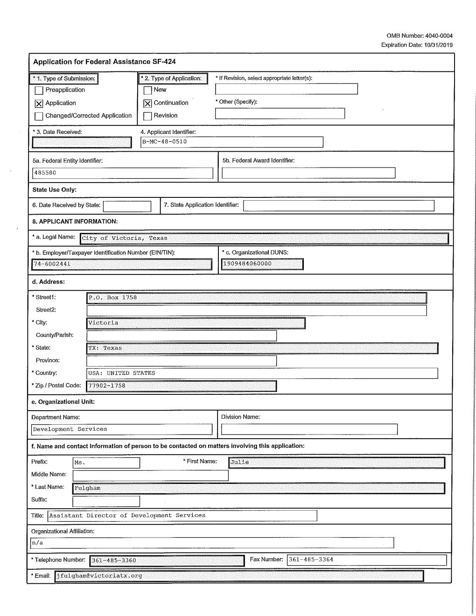
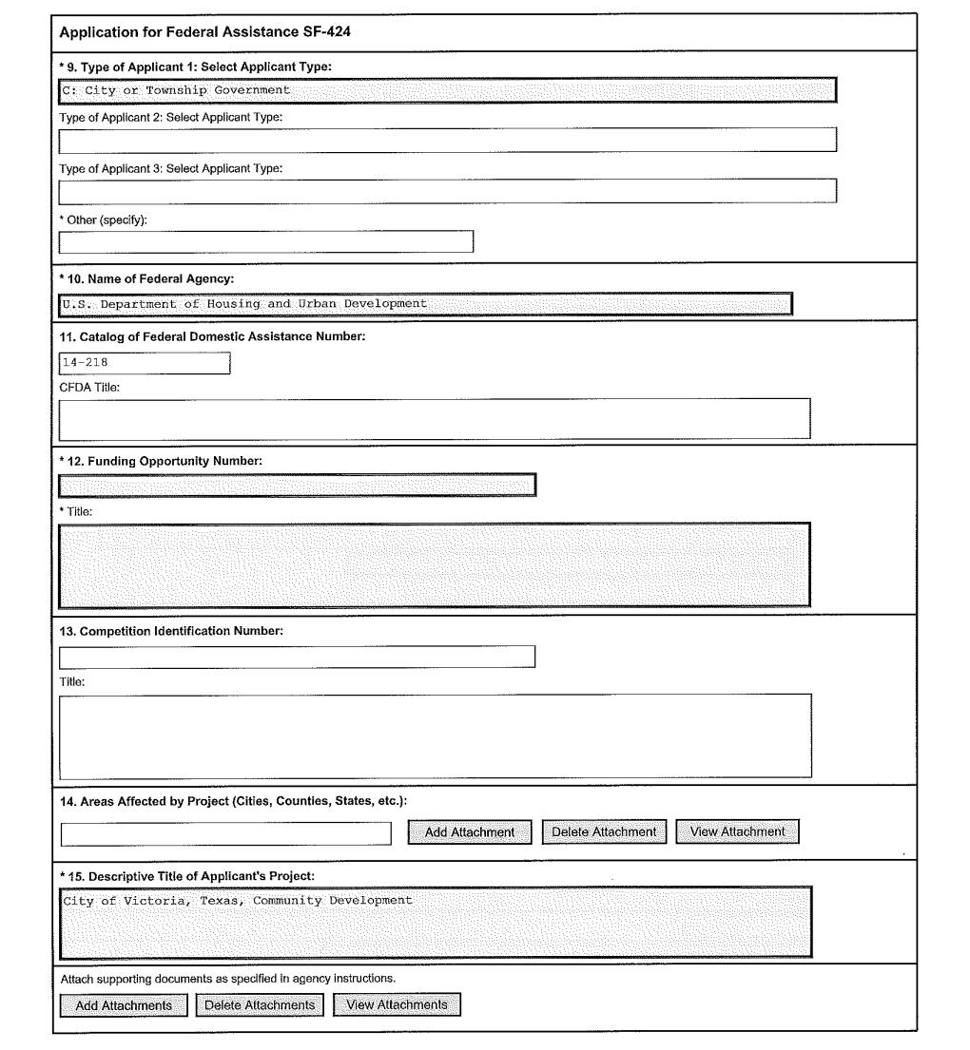
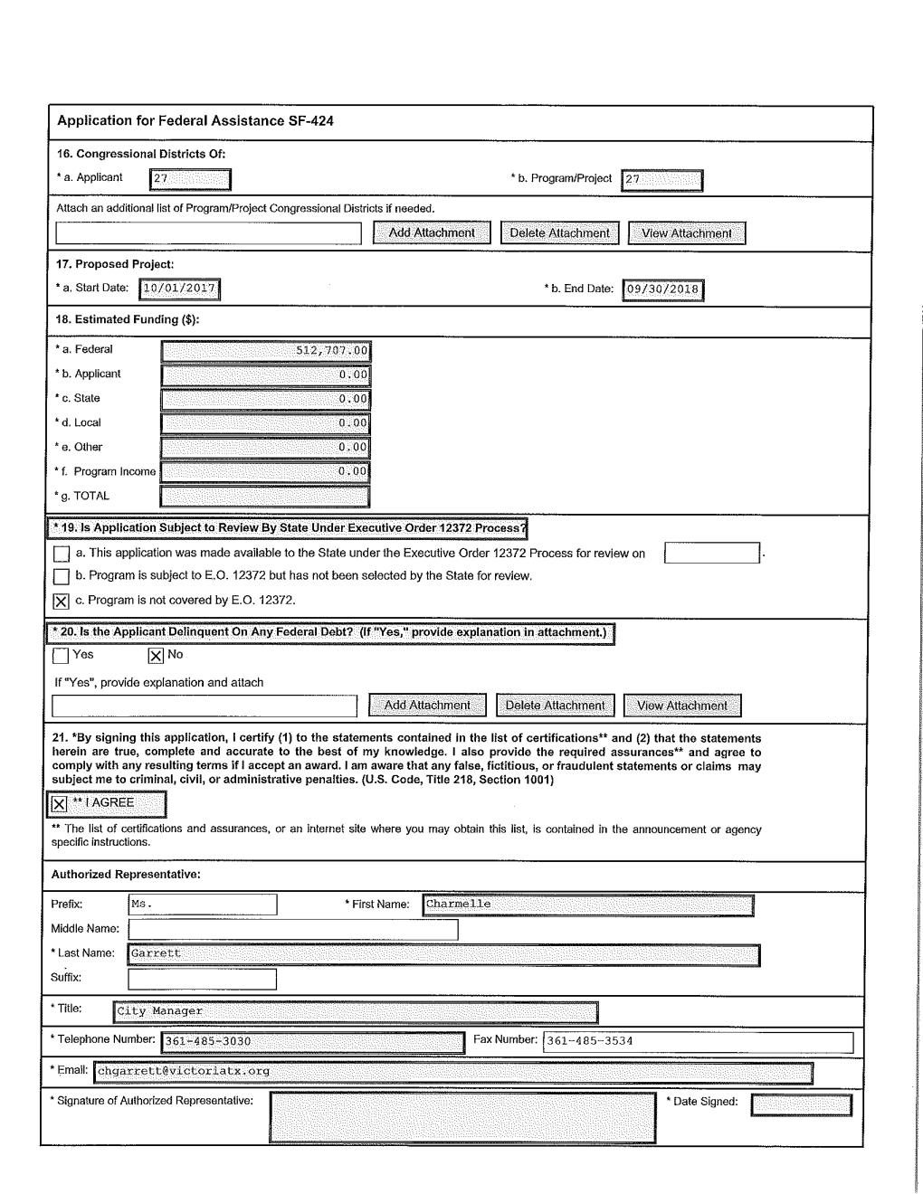

Funding Distribution

The following chart displays the breakdown of funding among six program areas: Program Administration, Neighborhood Programs, Public Services, Affordable Housing, Public Facilities, and Public Improvements. CDBG program regulations require the Program Administration budget, which includes salaries and supplies as well as planning and capacity building activities, to be less than 20% of the CDBG entitlement grant. The Program Administration budget is $92,588, which is approximately 18.059% of the 2017-2018 entitlement grant funds of $512,707.00. CDBG program regulations also require the Public Service Agencies budget to be less than or equal to 15% of the entitlement grant, and it may utilize up to 15% of the current year program income receipted. The Public Services budget is $80,281, which is 15% of the entitlement grant for $76,906 plus program income of $3,375.

Program Area | Funding Amount
Program Administration | $92,588.00
Neighborhood Programs | $48,283.00
Public Services | $80,281.00
Affordable Housing | $15,116.00
Public Facilities | $120,00.00
Public Improvements | $177,095.00
Total Program Funding | $533,363.00

Funds Available
2017 CDBG Grant | $512,707.00
Reprogrammed Budget | $20,656.00
Total Funds Available | $533,363.00

3. Evaluation of Past Performance Activities

The 2015-2019 Consolidated Plan continues the focus of the previous Consolidated Plan submitted by the City of Victoria. This plan continues to move toward projects and programs that will improve the quality of life for a larger portion of our community, instead of a direct housing focus. After a review of community needs for the 2015-2019 Consolidated Plan and HUD’s definition of prioritization, the City of Victoria has determined that while housing rehabilitation is a need in the community and an eligible expense of CDBG funds, CDBG funds will be used instead for community development and public services due to reduced budgets and costs associated with rehabilitation. Therefore, housing rehabilitation is still a need, but due to funding it is a lower priority in Victoria.

The 2017-2018 Action Plan is the third one-year plan under the 2015-2019 Consolidated Plan and continues to reflect this change in focus. The proposed activities address several community needs and issues that may not have been adequately addressed in previous years. Activities for the 2017 Program Year have been developed to address the goals and objectives from the 2015-2019 Consolidated Plan. The goals and objectives under the current five-year plan are identified in the above table.

4. Summary of Citizen Participation and consultation process
To encourage the continuing involvement of citizens in the HUD-sponsored programs administered by the City of Victoria, the city will continue to communicate openly about CDBG and other HUD programs with its partners and with the public as outlined in the Citizen Participation Plan. Throughout the one-year period covered by this plan, the city will sponsor public meetings and consultations to encourage citizen participation in the development of the annual Action Plan, proposed programs and to evaluate the city’s performance during the previous program year. These meetings represent opportunities for the public to be involved in housing and community development activities in the City of Victoria.

The City Manager's Reports, PSA workshop, one-on-one consultations, public meetings and public hearings are tools to obtain citizen participation for the needs, objectives and goals to determine the 3rd year Action Plan and the 2015-2019 Consolidated Plan & Strategy amendment. Those priorities of the goals are translated into the goals for the 2017-2018 Annual Action Plan. In preparation for the 2017-2018 Action Plan and Con Plan amendment, the City involved residents and stakeholders to the greatest extent possible through various meetings listed in the AP-10.

The City will conduct all of its Community Development activities to encourage ample citizen participation in the CDBG program. Given the delay in appropriations and the need for HUD to award the funds and the City of Victoria to address community development needs, pursuant to 24 CFR 91.600, the City is requesting the use of this waiver for the public participation period from standard 30-day citizen comment period in 24 CFR 91.105(b)(4) and 24 CFR 91.115(b)(4) and institute a minimum of a 14-day comment period. This waiver is necessary for the City of Victoria to utilize this shortened public comment period and provide the citizens a meaningful public comment period.

5. Summary of public comments
Through an extensive participation process, the public comments will be summarized in the AP-12 and all public comments were accepted and recorded. The Public Participation Plan is summarized as follows:
A Citizen Participation Plan is a required part of the consolidated planning process (24 CFR 91.105). Although the regulations do not require a formal structure for citizen participation, they do state that citizens shall be involved in the prioritizing and planning of Community Development Block Grant (CDBG) activities. In an effort to permit public examination and to enhance public accountability, the City of Victoria will make the following information available to citizens, public agencies and other interested parties upon request.
The public participation comments received during the 14-day period at the City Council Manager’s report on July 18, 2017 are as follows: John Kaminski, Assistant City Manager, presented to City Council the draft 1-Year CDBG Action Plan. Mr. Kaminski reported that this is the 3rd year of the 2015-2020 Consolidated Plan & Strategy. The City of Victoria will utilize 2017 HUD CDBG funds totaling $512,707, reprogrammed funds for $20,656 for a total of $533,363. This was an increase of approximately $8,000 based on last year’s budget. The comments received were as follows:
● Councilwoman Soliz asked if LED lights would be installed down Rio Grande. Mr. Kaminski referred the question to Mr. Gill for further remarks and he reported that AEP will upgrade the wattage of the lights along the corridor and the City would update lights at the signals to LED. Councilwoman Soliz had an additional reply that the Rio Grande area was very dark.
● Mayor Polasek commented that he was very exciting that the Public Improvement projects would bring increased visibility for driving and pedestrian safety.
● Mayor Polasek and City Manager Charmelle Garrett both responded that many of the CDBG subrecipients were in the audience, that the CDBG program was very data intensive, and that they did a very good job.
The public hearing and a resolution approving the CDBG Grant 2017-2018 One Year Action Plan was brought to City Council on August 1, 2017, authorizing the City Manager to submit all required documentation and amendments to HUD and declaring an effective date. During the City Council meeting, the Public hearing was called and City Council had no question for Mr. Kaminski nor where there any comments and the public hearing was closed. The resolution was approved on August 1, 2017 to submit the 3rd Year CDBG Action Plan by City Council. The CDBG funds will be available for expenditure for the period from October 1, 2017 to September 30, 2018.
6. Summary of comments or views not accepted and the reasons for not accepting them
All agency types which required to be consulted were consulted so there is no rationale for not consulting.
7. Summary

During the 2017-2018 program year the City of Victoria will utilize 2017 CDBG funds totaling $512,707.00 and reprogrammed 2015 funding for $20,656.00, for a total of $533,363.00. During the 2017 Program Year approximately 15.05% of funding which is 15% of grant max and 15% of 2016 Program Income in combination will go to public services, 22.50% to public facilities and 33.20% of funds will go towards public improvements. The 2015-2019 Consolidated Plan continues the focus of the previous Consolidated Plan submitted by the City of Victoria. This plan continues to move toward projects and programs that will improve the quality of life for a larger portion of our community instead of a direct housing focus. The City of Victoria actively looks for Citizen Participation opportunities when developing the action plan. This year the City of Victoria provided a Social Service Provider Workshop and 14 stakeholders attended. All comments made were accepted for review on the action plan.

Detailed maps are attached to show the low to moderate Housing and Area Benefit projects and the percentage of minority concentration for all projects within the 2017-2018 CDBG Action Plan.

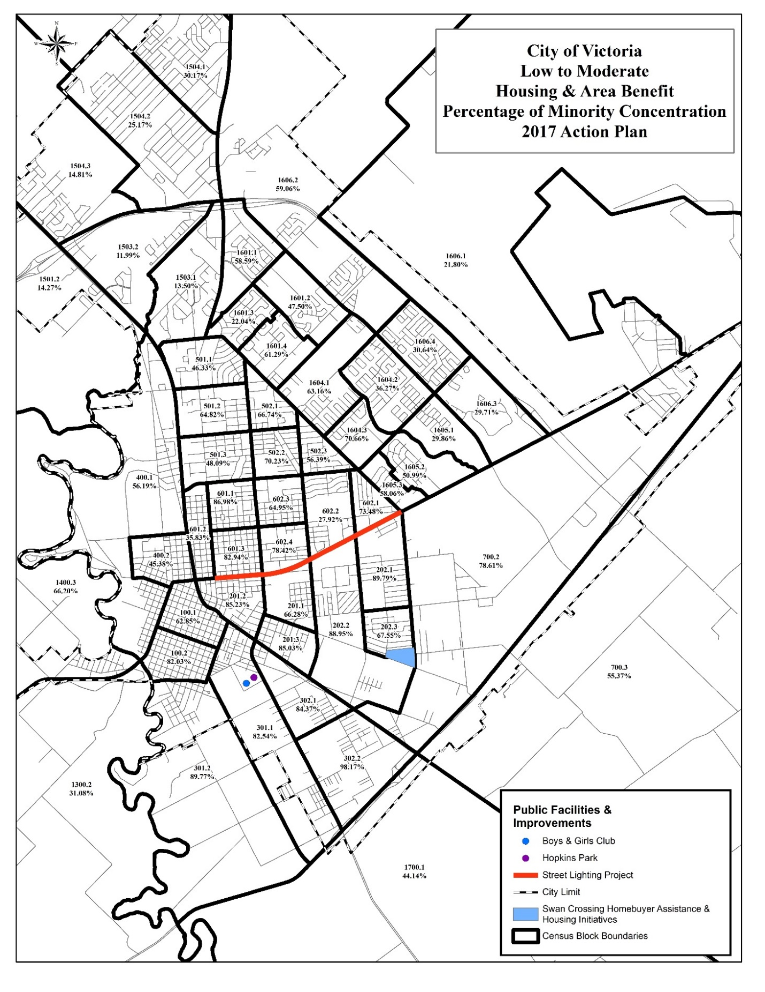
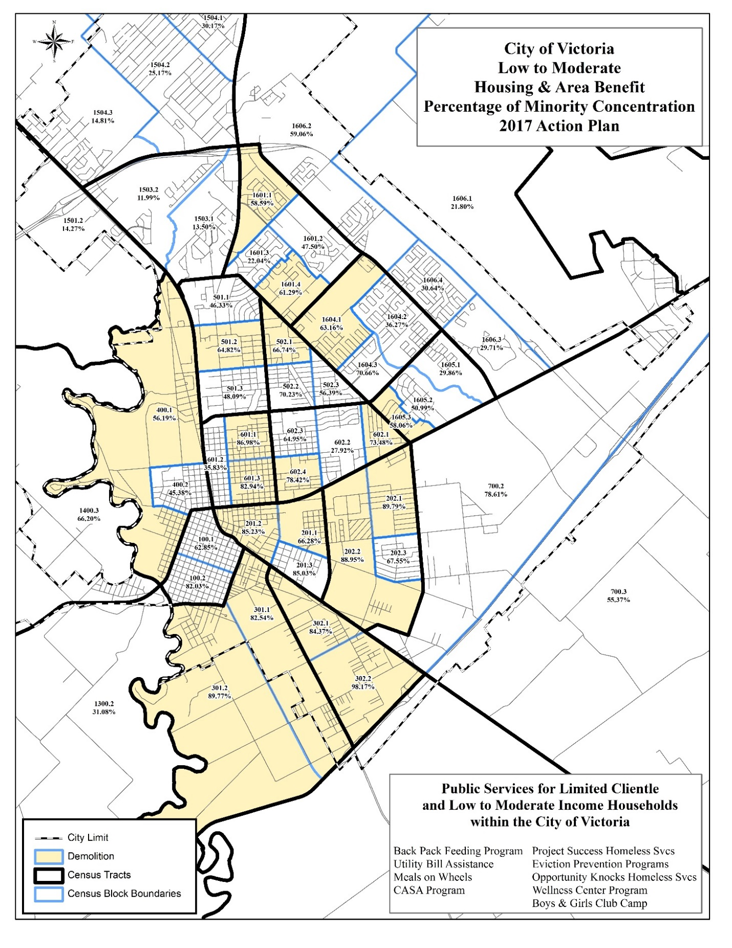
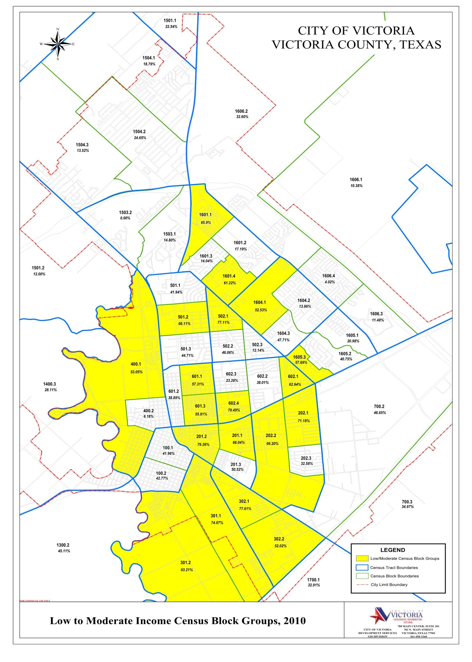

PR-05 Lead & Responsible Agencies – 91.200(b)
1. Agency/entity responsible for preparing/administering the Consolidated Plan
Describe the agency/entity responsible for preparing the Consolidated Plan and those responsible for administration of each grant program and funding source.
Agency Role | Name | Department/Agency
CDBG Administrator | VICTORIA | City of Victoria, Texas
Table 1 – Responsible Agencies

Narrative (optional)
The Development Services Department - Planning Division administers the CDBG program with assistance from the Finance Department that provides the separation of duties and is responsible for processing the IDIS draws and manages the grant funding. Public Works and Parks & Recreation Departments are also involved for implementing in-house public infrastructure projects. The City’s Legal Office writes all CDBG contracts and is consulted for legal opinions and for contract issues with sub-recipients.
Consolidated Plan Public Contact Information

City of Victoria, Texas
Darlah Sims, Community Development Coordinator
702 N. Main
Victoria, Texas 77901
(361)485-3360

ACTION PLAN

AP-10 Consultation – 91.100, 91.200(b), 91.215(I)

1. Introduction
The City of Victoria's 2017-2018 Action Plan is developed in response to the requirements of the U.S. Department of Housing and Urban Development (HUD). The one-year Action Plan serves as the strategic plan and application for funding under the Community Development Block Grant (CDBG) for the 2017-2018 Program Year. The plan describes community needs, resources, priorities, and proposed activities to be undertaken with CDBG funds. Community representatives, sub-recipients, public service agencies, private sector partners, Victoria Area Homeless Coalition members and City Council, provide input into the department's plans for HUD funding in on-going consultations and collaborations.
For the Action Plan, the City hosted a Public Services and Public Facilities Application Workshop, with non-profits and facility representatives. One-on-One consultations were held to acquire more comprehensive information about priority needs, goals, objectives, and funding issues throughout the year. Due to budgeting setbacks, HUD has approved a shortened public participation period from 30-day citizen comment period to a 14-day period. The required 14-day public review comment period will be held from July 17, 2017 to August 1, 2017. Additionally, efforts were made to integrate existing community plans such as the Continuum of Care, which addresses homeless issues, and the City of Victoria Comprehensive Plan, which is a master plan dealing with all aspects of city government. The summary of the citizen participation is located on Page 14 of the Executive Summary.
In order to encourage the continued involvement of citizens in the HUD-sponsored programs administered by the City of Victoria, the city will continue to communicate openly about CDBG and other HUD programs with its partners and with the public as outlined in the Citizen Participation Plan. Throughout the one-year period covered by this plan, the city will sponsor public meetings and consultations to encourage citizen participation in the development of the Annual Action Plan, proposed programs and to evaluate the city’s performance during the previous program year. These meetings represent opportunities for the public to be involved in housing and community development activities in the City of Victoria.
Provide a concise summary of the jurisdiction’s activities to enhance coordination between public and assisted housing providers and private and governmental health, mental health and service agencies (91.215(I)).
The Action Plan was developed with a strong emphasis on community input. The Development Services Department consultations consist of public outreach with a number of housing and community development professionals. Institutional coordination of the Action Plan establishes a unified vision for community development. The City uses a collaborative process to work closely with its sub-recipients and other service providers to shape various programs into effective, coordinated strategies. The City will execute this Action Plan in harmony with public, private and non-profit agencies to design programs that address identified needs.
The City of Victoria involved public and private housing, health, mental health and service agencies in a number of ways such as the involvement in the Victoria Area Homeless Coalition (VAHC), which includes not only homeless service providers but health, mental health, substance abuse treatment, and housing providers as well as local businesses. On May 11, 2017, a Workshop for Public Service agencies and facilities was held to discuss the needs in the community, how the needs were being met and how the groups could enhance coordination and collaboration.
The Development Services Department has a working relationship with the Victoria Public Housing Authority. The City is the responsible entity to ensure the Victoria Public Housing Authority's plans are consistent and continue to provide the much needed housing for the low-income person, families, elderly and disabled residents in the City of Victoria. The City of Victoria Code Enforcement works directly with the U.S. Department of Health and Human Services (HHS), a governmental health agency for cases needing additional intervention. The HHS is a proven resource to provide essential human services for elderly and disabled residents that are living in substandard housing or situations that are not suitable for human habitation.
Gulf Bend Wellness Center provides a mental health facility that serves the disabled persons in the City of Victoria. The 32-bed housing facility center that was recently completed provides transitional housing. The facility has 32 units that provide the residents with counseling, life skills, comprehensive personalized support, medical and medication stability and housing for up to 24 months. The workshop and one-on-one meetings allow and enhance the communication and cooperation among non-profit, private and public facility organizations working to improve and provide the essential services in Victoria.
Describe coordination with the Continuum of Care and efforts to address the needs of homeless persons (particularly chronically homeless individuals and families, families with children, veterans, and unaccompanied youth) and persons at risk of homelessness.
The coordination of the Continuum of Care (CoC) has utilized their funding to the maximum through their assistance provided for homeless persons. The Gateway Program provides permanent supportive housing for the chronic homeless men. The HopeNet assists women with disabilities by providing permanent supportive housing to disabled women to help reduce homelessness, increase stability and improve their quality of life. Next Step is a supportive housing program. These programs are vital assets to the community. In addition to working with the Homeless Coalition on the CoC grant and through consultation meetings, the CoC service provides needs identification for the strategic plan. The City of Victoria continues to coordinate and support the CoC's plan. The coordination of the CoC has utilized their funding to the maximum through their assistance provided for the homeless persons. The areas of improved coordination is the limited number of partners that are (501) (c) (3) non-profit status and volunteer labor. Additional non-profit meetings will continue to improve the communication between agencies.

Describe consultation with the Continuum(s) of Care that serves the jurisdiction's area in determining how to allocate ESG funds, develop performance standards and evaluate outcomes, and develop funding, policies and procedures for the administration of HMIS
The City of Victoria's CoC funding is administered by Mid-Coast Family Services (MCFS), the lead agency through one-on-one collaborations and consultations. The City works closely with the agency and other agencies serving homeless persons, and the needs of individuals and families experiencing homelessness.

Emergency Shelter Grant (ESG) funded programs have played a significant role in reducing the number of individuals/families who become homeless by funding preventative programs in the CoC. Texas Homeless Network serves as the lead, HMIS administrator and the collaborative applicant for the HUD (CoC) Balance of State. Texas Homeless Network in collaboration with MCFS has established a very close inter-agency collaboration to ensure that homeless persons are linked to services best suited for their needs. In grant collaboration, MCFS has collaborated with Community Action Committee of Victoria to apply for the maximum additional ESG funding available to the CoC for $150,000. The ESG funds for homeless prevention utilized through stabilization, domestic violence and rapid re-housing of homeless persons. The competitive award announcements are during the 3rd quarter of 2017 with a start date of November 1, 2017, if successful in the grant award renewal.
The allocation of the ESG funds will provide 50% to homeless prevention, 30% shelter, 10% to street outreach and 10% for Housing Management Information System (HMIS) support. The performance standards, that are in place for the ESG funding are the Federal Best Practices with the evaluation of outcome completed through the follow-up with clients quarterly and semi-annually and assess the service satisfaction. The Policy and Procedure guidelines will be the Board of Directors guidance bringing their expertise from all fields and one Board position, which is held by a formerly homeless person.

2. Describe Agencies, groups, organizations and others who participated in the process and describe the jurisdictions consultations with housing, social service agencies and other entities.

Table 2 – Agencies, groups, organizations who participated
1 | Agency/Group/Organization | MID-COAST FAMILY SERVICES, INC.
1 | Agency/Group/Organization Type | Housing  Services9 - Housing  Services-Victims of Domestic Violence  Services-homeless  Services – Victims
1 | What section of the Plan was addressed by Consultation? | Housing Need Assessment  Homeless Needs - Chronically homeless  Homelessness Strategy
1 | Briefly describe how the Agency/Group/Organization was consulted. What are the anticipated outcomes of the consultation or areas for improved coordination? | Mid-Coast Family Services (MCFS) is a past sub-recipient of Public Facility funding and PSA funding. The agency provides the Women Crisis Center for battered women and services for the homeless. The City has worked closely with Mid-Coast by consulting with and facilitating the coordination of the shelter and office and therapy rooms for both the shelter and offices. Will continue to coordinate with for the additional beds for the homeless and battered victims. Mid-Coast Family Services is the recipient of the Continuum of Care (CoC) that provides the much-needed transitional shelter for the chronic homeless men and women. The agency helps to determine the level of continued need and goals to meet the need as an agency and a sub-recipient. A new partnership has been with Community Action Committee and the CoC. A continued need is for an improved coordination between the agencies to meet outside of the Homeless Coalition meetings, increase communication, and streamline the information necessary from one agency to the other.
2 | Agency/Group/Organization | Perpetual Help Home
2 | Agency/Group/Organization Type | Housing  Services - Housing  Services-Victims of Domestic Violence  Services-homeless  Services-Employment
2 | What section of the Plan was addressed by Consultation? | Homeless Needs - Families with children  Homelessness Strategy
2 | Briefly describe how the Agency/Group/Organization was consulted. What are the anticipated outcomes of the consultation or areas for improved coordination? | Perpetual Help Home a past sub-recipient of Public Service Agency CDBG funding attended the workshop and consultation. The Center for Peace created the Opportunity Knocks and the Acceleration Program with the instructors for the program demonstrating leadership and empowerment they have experienced and hope to pass on to others. Job skills are taught through modules, some direct instruction and some individual paced self-instruction. Areas for improvement in coordination provide periodic meetings with the CoC to increase networking for the homeless and at-risk homeless persons.
3 | Agency/Group/Organization | KIDZconnection - Victoria Independent School District
3 | Agency/Group/Organization Type | Services-Children  Services-homeless  Services-Education
3 | What section of the Plan was addressed by Consultation? | Homeless Needs - Families with children  Homelessness Needs - Unaccompanied youth
3 | Briefly describe how the Agency/Group/Organization was consulted. What are the anticipated outcomes of the consultation or areas for improved coordination? | The Victoria Independent School District KIDZconnection a past sub-recipient for Public Service Agency CDBG funding has attended the workshop and had many one-on-one consultations. The agency provides the basic needs for the homeless and at-risk-homeless families. Project Success assists in case management directly for the student to remove the barriers that impede their academic success. A continued need is for improved coordination between the agencies to meet outside of the Homeless Coalition meetings, increase communication, and streamline the information necessary from one agency to the other.
4 | Agency/Group/Organization | Housing Authority of the City of Victoria
4 | Agency/Group/Organization Type | PHA  Services - Housing  Services-Elderly Persons  Services-Persons with Disabilities
4 | What section of the Plan was addressed by Consultation? | Public Housing Needs  Non-Homeless Special Needs
4 | Briefly describe how the Agency/Group/Organization was consulted. What are the anticipated outcomes of the consultation or areas for improved coordination? | The Housing Authority for the City of Victoria (PHA) discussed within a consultation that the most difficult areas that are in need of improvement is resident involvement. The PHA will continue to keep trying to solicit the residents to participate. Changes have continued to plague the Housing Authority and continue to work through an OIG investigation.
5 | Agency/Group/Organization | Community Action Committee of Victoria
5 | Agency/Group/Organization Type | Services - Housing  Services-Elderly Persons  Services-Persons with Disabilities  Other-Partnering with CoC
5 | What section of the Plan was addressed by Consultation? | Non-Homeless Special Needs
5 | Briefly describe how the Agency/Group/Organization was consulted. What are the anticipated outcomes of the consultation or areas for improved coordination? | Community Action Committee of Victoria is a past sub-recipient of CDBG funding and was unable to attend the workshop due to a national conference they were attending. They receive funding from TDHCA for weatherization and utility assistance. Through CDBG a 5-days a week for the Meals-On-Wheels program and utility assistance to at least 100 families. They are continuing the collaboration with Mid-Coast Family Services, for additional Emergency Solutions Grant (ESG) renewal funding in July. An additional collaboration is with the Area Agency on Aging at the Golden Crescent Regional Planning Commission to provide a coordinated system of information and access information on services, support, and provide handicap accessibility for elderly or disabled persons. The improved coordination is continually accessing programs and agencies to provide assistance.
6 | Agency/Group/Organization | Golden Crescent Court Appointed Special Advocates
6 | Agency/Group/Organization Type | Services - Housing  Services-Children  Services - Victims  Child Welfare Agency
6 | What section of the Plan was addressed by Consultation? | Presumed Benefit Clientele
6 | Briefly describe how the Agency/Group/Organization was consulted. What are the anticipated outcomes of the consultation or areas for improved coordination? | CASA is a past sub-recipient for Public Service Agency CDBG funding, attended the PSA workshop, and have had a one-on-one consultation. The agency provides the basic needs for the neglected and abused children that become wards of the State. Closely works with the agency to ensure any issues of confidentiality are met. CASA are trained volunteers that are court appointed special advocates for the children's best interests of children placed in the foster care system.
7 | Agency/Group/Organization | Faith Family Church
7 | Agency/Group/Organization Type | Services - Housing  Services-homeless
7 | What section of the Plan was addressed by Consultation? | Homeless Needs - Families with children
7 | Briefly describe how the Agency/Group/Organization was consulted. What are the anticipated outcomes of the consultation or areas for improved coordination? | Faith Family is a past sub-recipient of eviction prevention PSA funding. The agency attended the workshop and the City has met with them many times. They have reopened the shelter called the House of Palms, which is a transitional housing shelter for pregnant teenage girls and has a capacity of 10 girls and their babies. They also have an eviction prevention program and a neighborhood cleanup. They have continued to work with Queen City neighborhood as an Adopt-a-Block for debris removal, minor repair and/or painting of the homes currently working in 12 blocks on the first Saturday of the month. An effort that needs continued partnership is between Mid-Coast Family Services and Salvation Army to coordinate homeless housing in the most effective way.
8 | Agency/Group/Organization | Habitat for Humanity of Victoria
8 | Agency/Group/Organization Type | Housing  Services - Housing
8 | What section of the Plan was addressed by Consultation? | Non-Homeless Special Needs
8 | Briefly describe how the Agency/Group/Organization was consulted. What are the anticipated outcomes of the consultation or areas for improved coordination? | Golden Crescent Habitat of Humanity is a past sub-recipient of CDBG funding has met for a one-on-one consultation. Habitat is the community's only participating, new housing construction agency. They have constructed 99 homes in Victoria with 1 home currently under construction for low-income homebuyers. Habitat for Humanity is now constructing homes in a subdivision that is not within a CDBG-eligible Census block group and no eligible Habitat location is expected to be available within the remaining years of the current CPS.
9 | Agency/Group/Organization | The Salvation Army
9 | Agency/Group/Organization Type | Housing  Services - Housing  Services-homeless
9 | What section of the Plan was addressed by Consultation? | Homeless Needs - Families with children
9 | Briefly describe how the Agency/Group/Organization was consulted. What are the anticipated outcomes of the consultation or areas for improved coordination? | The Salvation Army is a past sub-recipient of both Public Facility funding and PSA funding. Salvation Army is the only men's shelter in Victoria. They have developed a "Stepping Stone" Program, which is a rehab program for drug, and alcohol addicted persons with a 30-day lock in component for the men enrolled in the program. One significant item needed for the chronically homeless men is improved coordination of mental health services and continued assistance to see the men back to self-sufficiency.
10 | Agency/Group/Organization | Food Bank of the Golden Crescent
10 | Agency/Group/Organization Type | Services-Children  Sustenance - Food Bank
10 | What section of the Plan was addressed by Consultation? | Homeless Needs - Families with children
10 | Briefly describe how the Agency/Group/Organization was consulted. What are the anticipated outcomes of the consultation or areas for improved coordination? | The Food Bank of the Golden Crescent is a past sub-recipient of CDBG funding and was invited to the workshop. The Food Bank distributes 1.3 million pounds of food to Victoria, feeding many at-risk homeless and homeless persons through other agencies. They have a backpack program for the elementary school students that are homeless in the City. They are doing street outreach in the form of a mobile pantry and nutrition.
11 | Agency/Group/Organization | Boys & Girls Club of Victoria
11 | Agency/Group/Organization Type | Services-Children
11 | What section of the Plan was addressed by Consultation? | Non-Homeless Special Needs
11 | Briefly describe how the Agency/Group/Organization was consulted. What are the anticipated outcomes of the consultation or areas for improved coordination? | The Boys & Girls Club are a past sub-recipient of CDBG Public Facility and PSA funding and attended the PSA and Public Facility workshop to discuss the children and youth needs. Improved facilities of the rear section of the facility is in the beginning stages of planning and renovation. Through this upgrade, the Boys and Girls Club will bring in additional 13-18 year-olds involved in new activities and attractions to keep the children engaged in positive activities and a structured atmosphere.
12 | Agency/Group/Organization | GULF BEND MHMR CENTER
12 | Agency/Group/Organization Type | Services-Persons with Disabilities  Services-Health  Services-Education  Health Agency
12 | What section of the Plan was addressed by Consultation? | Non-Homeless Special Needs  Presumed benefit clientele
12 | Briefly describe how the Agency/Group/Organization was consulted. What are the anticipated outcomes of the consultation or areas for improved coordination? | Gulf Bend is a past sub-recipient of CDBG Public Facility funding who have met in a one-on-one consultation and attended the PSA workshop. Gulf Bend is the provider of services for a very special segment of the population of those persons experiencing severe mental illness, specifically the mentally ill. The Center also addresses the needs of persons with intellectual functioning and developmental disabilities and related conditions. They continue to see a need for affordable housing for persons with special needs.

Identify any Agency Types not consulted and provide rationale for not consulting

All agency types required were consulted so there is no rationale for not consulting.

Other local/regional/state/federal planning efforts considered when preparing the Plan
Name of Plan | Lead Organization | How do the goals of your Strategic Plan overlap with the goals of each plan?
Continuum of Care | Mid-Coast Family Services | The goals of the Strategic Plan and the Continuum of Care (COC) must be coordinated to ensure all funding requirements are met as the Responsible Entity for the COC grant funding, reviews and the release of the funding.
Table 3 – Other local / regional / federal planning efforts

Narrative (optional):
As an entitlement City, Victoria receives CDBG dollars to invest in the community. The City of Victoria involved public and private housing, health, mental health and service agencies in a number of ways. During the workshop the stakeholders collaborated, discussed needs, and set priority needs. Additional information was gathered during one-on-one consultations.
TABLE 4(A): Other Local/Regional/State/Federal Planning Efforts Considered when Preparing the Plan
Name of Plan Lead Organization | Goals of your Strategic Plan overlap with the goals of each plan
City of Victoria, Texas Comprehensive Plan | Priority Needs, Market Conditions, Goals,
City of Victoria, Texas Metropolitan Planning Organization | Priority Needs, Goals
Golden Crescent Regional Area Agency on Aging | Priority Needs and Goals
Victoria Public Housing | Priority Needs and Public Housing Accessibility and Involvement and Goals
TABLE 4(B): OTHER CONSULTATIONS & COORDINATION
Organization/Agency Coordination
Organization | Agency-Coordination
City of Victoria Public Works Dept. | Assisted in public improvements and enhancements of City infrastructure
City of Victoria Parks and Recreation Dept. | Assisted in public improvements of Park projects
Victoria Area Homeless Coalition | Monthly meeting with non-profits and citizens in Victoria helping to end homelessness
Victoria Alliance | Priority Needs and Goals
Mid-Coast Family Services CoC | Homeless Strategy, Priority Needs and Goals

AP-12 Citizen Participation– 91.105, 91.200(c)
1. Summary of citizen participation process/Efforts made to broaden citizen participation. Summarize citizen participation process and how it impacted goal-setting
The summarization of all citizen participation processes are exhibited described in the following. The City of Victoria has membership in the Victoria Area Homeless Coalition (VAHC). A description of the Consolidated Plan is to identify the needs, describe the priorities and strategies and to report specific demographics for the City of Victoria. The Public Service Agency and Public Facility workshop was held on May 11, 2017. The information presented gave the needed exposure to agencies that are not current recipients of CDBG funding. The at-risk homeless and homeless supportive services and facilities were identified in the Consolidated Plan as a high need and continue to be identified as a goal for the City of Victoria.
Consultations were held with providers throughout the program year and individually during the first quarter of the year. Information was provided to the Victoria Area Homeless Coalition (VAHC) during the April meeting to discuss the amended CPS and that we would be taking applications in May. On June 29, 2017 a presentation of the Executive Summary to the VAHC discus the draft CDBG Action Plan funding recommendations. On July 18, 2017, a City Manger’s Report will be held to discuss with City Council the draft Action Plan and the PSA funding recommendations for the One-Year Action Plan. On August 1, 2017, the final Public Hearing and resolution to adopt the CDBG Action Plan will be held for City Council adoption.
All of the City Manager’s Reports, workshop, one-on-one consultations, public meetings and public hearing were tools to obtain citizen participation for the needs, objectives and goals to determine the 3rd year Action Plan. Those priorities, then translated into the goals for the 2017-2018 Annual Action Plan.

Citizen Participation Outreach
Sort  Order | Mode of  Outreach | Target of Outreach | Summary of  response/attendance | Summary of comments received | Summary of  comments not accepted and reasons | URL (If applicable)
1 | One-on-One consultations | Non-Profit Service providers and public facility agencies | January through May 2017, one-on-one consultations were held with service providers and public facility to discuss the future activities. | One-on-one consultations held and specific discussions and comments are contained in the AP-10 Consultation. Continual discussion on the 15% PSA cap on public service agency funding and total annual budget of approximately $500,000. | All comments were accepted into the plan so there is no reason for further comment.
2 | PSA & Public Facility Workshop | Non- Profit Service providers and public facility agencies | May 11, 2017 a workshop was held to discuss application for PSA’s and Public Facility activities and needs. | 16 agencies attended the pre-application workshop. | All comments were accepted into the plan so there is no reason for further comment.
3 | Public Meeting | Homeless and At-Risk Homeless Service Providers | Information was provided on April 27, 2017 at the Pine Street Community Center to discuss the amended ConPlan and all responses were included. | An overview packet was handed-out concerning CDBG Public Service Agency grants purpose, guidelines, objectives and eligible programs. The summary of comments received were as follows:  - Additional information on the Eviction Prevention Program  - Intake procedures.  - A discussion was undertaken concerning the priority ranking of clients on a monthly basis. | All comments were accepted into the plan so there is no reason for further comment.
4 | Public Meeting | Homeless and at-Risk Homeless Service Providers | Information was provided on June 29, 2017 at the Pine Street Community Center to discuss the Executive Summary. | The Executive Summary of the 2017-2018 Annual Action Plan recommendations for the Public Service Agency and Public facility funding was handed out for discussion. Twenty (20) people agency representatives attended the public meeting. The comments received were as follows:  - Discussion concerning the budget set by Congress that what if the HUD CDBG grant was no longer available; would the City’s General fund absorb the CDBG Public Service Agency funding? The reply was that at this time the city would not absorb any of the CDBG funding. | All comments were accepted into the plan so there is no reason for further comment.
5 | City Manager’s Report to City Council Public Meeting | Non-targeted/ broad community | The July 18, 2017, City Council Manager’s Report was held to review the funding recommendations for the 3rd Year Action Plan all responses were recorded. All seven Council Members were in attendance. | John Kaminski, Assistant City Manager, presented to City Council the draft 1-Year CDBG Action Plan. Mr. Kaminski reported that this is the 3rd year of the 2015-2020 Consolidated Plan & Strategy. The City of Victoria will utilize 2017 HUD CDBG funds totaling $512,707, reprogrammed funds for $20,656 for a total of $533,363. This was an increase of approximately $8,000 based on last year’s budget. The comments received were as follows:  ● Councilwoman Soliz asked if LED lights would be installed down Rio Grande. Mr. Kaminski referred the question to Mr. Gill for further remarks and he reported that AEP will upgrade the wattage of the lights along the corridor and the City would update lights at the signals to LED. Councilwoman Soliz had an additional reply that the Rio Grande area was very dark.  ● Mayor Polasek commented that he was very exciting that the Public Improvement projects would bring increased visibility for driving and pedestrian safety.  ● Mayor Polasek and City Manager Charmelle Garrett both responded that many of the CDBG subrecipients were in the audience, that the CDBG program was very data intensive, and that they did a very good job.  The Action Plan public hearing will be held during the City Council meeting on August 1, 2017 and then will be presented to Council for final approval. The CDBG funds will be available for expenditure for the period from October 1, 2017 to September 30, 2018. | All comments were accepted into the plan so there is no reason for further comment.
6 | Public Hearing | Non-targeted/ broad community | On August 1, 2017, the City Council will hold a final public hearing to approve a resolution to adopt the 3rd Year Action Plan. Notification will be given to the Public Service Agencies concerning the Public Hearing. | The public comment period was from July 17, 2017 through August 1, 2017. The summary of comments received was as follows:  The public hearing and a resolution approving the CDBG Grant 2017-2018 One Year Action Plan was brought to City Council on August 1, 2017, authorizing the City Manager to submit all required documentation and amendments to HUD and declaring an effective date. During the City Council meeting, the Public hearing was called and City Council had no question for Mr. Kaminski nor where there any comments and the public hearing was closed. The resolution was approved on August 1, 2017 to submit the 3rd Year CDBG Action Plan by City Council. The CDBG funds will be available for expenditure for the period from October 1, 2017 to September 30, 2018. | All comments were accepted into the plan so there is no reason for further comment.
Table 4 – Citizen Participation Outreach

AP-15 Expected Resources – 91.220(c)(1,2)
Introduction
The Five Year Consolidated Plan must identify the federal, state, local and private resources expected to be available to the City to address priority needs and specific objectives identified in the Strategic Plan. These resources are summarized in SP-35 of the 2015-2019 CDBG Consolidated Plan and Strategy.
The City of Victoria is anticipating $512,707 CDBG grant funds, $20,656 in unprogrammed monies that have been receipted in IDIS. With these funds, the City of Victoria can then choose how to use it over the course of the 2017-2018 program year and subsequent program years. During the course of this Five Year Consolidated Plan the City of Victoria is expected to receive $2,500,000 in CDBG funding. The available funds will be used for CDBG eligible activities consistent with the current goals and objectives identified in the Five -Year Consolidated Plan. CDBG funds will be used in housing and community development activities including, but not limited to, neighborhood programs, public services, affordable housing, public facilities, public improvements and program administration of the City's CDBG program.

Anticipated Resources
Program | Source of Funds | Uses of Funds | Expected Amount Available Year 2 |  |  |  | Expected Amount Available Remainder of Consolidated Plan $ | Narrative Description
Program | Source of Funds | Uses of Funds | Annual Allocation: $ | Program Income: $ | Prior Year Resources: $ | Total: $ | Expected Amount Available Remainder of Consolidated Plan $ | Narrative Description
CDBG | Public Federal | Acquisition, Program Administration  and Planning,  Economic Development, Housing,  Public Improvements,  Public Services | $512,707.00 | $ | $20,656.00 | $533,363.00 | $1,000,000 | Funds will be used according to the noted priorities to include Program Administration, Neighborhood Programs, Public Services, Affordable Housing, Public Facilities, and  Public Improvements
Table 1 - Expected Resources – Priority Table
Explain how federal funds will leverage those additional resources (private, state and local funds), including a description of how matching requirements will be satisfied
Within the City of Victoria, there is not currently a matching requirement to receive CDBG dollars. The non-profit partners in the City of Victoria are able to leverage funds with other private, state, and local funds in order to provide additional services and support for residents receiving assistance through the program.

If appropriate, describe publicly owned land or property located within the jurisdiction that may be used to address the needs identified in the plan
Not Applicable.
Discussion
The anticipated CDBG funding for the City of Victoria will address many city-wide goals, including improving neighborhood programs, public services, affordable housing, public facilities, public improvements and program administration. The Swan Crossing neighborhood has provided many affordable homes by giving first time homebuyers down payment and closing cost assistance and the project will be complete during the 2017-2018 program year and no program income is projected during the 2017-2018 program year. The total funding available for funding will be $533,363.

AP-20 Annual Goals and Objectives – 91.420, 91.220(c)(3)&(e)
Goals Descriptions
Sort Order | Goal Name/Activity | Start Year | End Year | Category | Geographic Area | Needs Addressed | Funding | Goal Outcome Indicator
1 | Youth Center/Facilities | 2017 | 2018 | Public Facilities | City-Wide | Provides safe, accessible and available environments by improving youth center facilities | $120,000 | Improve the youth center for at-risk, low-income children and youth by providing a suitable living environment that is available and accessible and is located within an area-benefit census block group with an average daily attendance of 125 children.
2 | Increase Affordable Rental Housing | 2017 | 2018 | Affordable Housing | City Wide | Continue to support developers who wish to utilize the Low-Income Housing Tax Credit Program that satisfy the standard requirements. | $0 | Continue to support the developers that satisfy the standard requirements of the Low Income Housing Tax Credit Program to provide affordable housing.
3 | Mortgage Assistance Program – Direct Home Ownership Assistance | 2017 | 2018 | Affordable Housing | City-Wide | Provides an increased availability of decent affordable homes to low-income homebuyers | $15,116 | Provide down payment and closing cost assistance for 6 low-income families or 15 persons.
4 | Clearance & Demolition | 2017 | 2018 | Non-Housing Community Development | Low and Moderate Income Census Block Groups | Provides sustainable and suitable living environment through the clearance of debris and removal of dilapidated structures from vacant or substandard property in targeted low and moderate income block group neighborhoods. | $48,283 | Clearance and demolition of 9 substandard properties to address neighborhood sustainability.
5 | Park Improvements- Public Improvements | 2017 | 2018 | Non-Housing Community Development | Low and Moderate Income Census Block Groups | Creating a suitable living environment by providing available and accessible parks projects through Public Improvement activities. | $145,000 | Make available assistance for the installation of a concrete Trail Project at the Hopkins with solar lighting. The neighborhood park provides availability and accessibility of a Parks project located in a low-income census block group and provides suitable living environment for 1,705 low-income residents.
6 | Street Lighting Project- Public Infrastructure Improvement | 2017 | 2018 | Public Improvements | Low and Moderate Income Census Block Groups | Providing a suitable living environment by providing the availability and accessibility of safer driving and pedestrian routes with street lighting improvements | $32,095 | This activity will upgrade the street lighting to provide and promote more suitable infrastructure that is safer, accessible, and available for both automobile and pedestrian routes in low and moderate-income census neighborhoods. Locations will be in high traffic corridor on Rio Grande between Navarro and Sam Houston. Upgrade of 39 lights and installation of 18 streetlights. A detailed map showing the locations of the street lighting improvements are presented in the map located in AP-05. The activity will assist low-income persons residing in the areas.
7 | Perpetual Help Home – Opportunity Knocks-Homelessness Prevention | 2017 | 2018 | Public Services | City Wide | Employment/ job training services for homeless women | $7,803 | Provide an affordable job training program through the Opportunity Knocks to 40 homeless women
8 | Gulf Bend MHMR Wellness Community- Public Service Activity /Mental Health & Wellness | 2017 | 2018 | Public Services | City Wide | Provide an increased availability of care for the severely disabled persons. | $9,688 | Provide accessible and available services/treatments for transitional housing, respite, outreach services, outpatient medical and counseling to 3 severely disabled persons at the Wellness Community on a daily basis for one year and 2 staff’s salary.
9 | VISD/ KIDZconnection-Public Service Activity for Children & Youth Services | 2017 | 2018 | Public Services | City Wide | Provide additional services to homeless school children | $10,000 | KIDZ-connection PSA activity assists 50 homeless students through “Project Success”, a program designed to address the needs of the homeless students by removing barriers that impede their ability to be academically successful. One full-time Project Success assistant for 578 hours is assigned to Patti Welder Middle School students and shelters. An individualized plan will be prepared to address the student’s challenges in attendance, academics, discipline, transportation, tutoring and other basic needs.
10 | Community Action Committee of Victoria-Public Service Activity /Senior and/or Disabled | 2017 | 2018 | Public Services | City Wide | Provide assistance through meals to the Seniors and Disabled. | $10,000 | Provide affordable Meals-on-Wheels program, provides 250 meals at $6.50 to 28 low-income elderly and/or disabled homebound persons with hot-meal 5-days a week and a daily wellness contact. The funding provides a portion of this approximately $47,000 activity.
11 | Community Action Committee of Victoria- Public Service Activity/ Subsistence Support Service | 2017 | 2018 | Public Services | City Wide | Provide payment assistance through Utility\Water bills to Low-Moderate Income individuals or families | $10,000 | Provide up to $100 annually for the water and sewer utility bill assistance to prevent disconnection and ensure affordable, healthy and sanitary living environments for 100 families/ 250 low-income persons.
12 | Food Bank of the Golden Crescent - Public Service Activity for Children & Youth Services | 2016 | 2017 | Public Services | City Wide | Provide weekly backpacks with food for weekends and holidays for homeless students. | $10,000 | Provide accessible and available healthy backpacks to 67 students at 5 schools for $5.00 each on weekends and holidays when free school lunches are not available.
13 | CASA –Golden Crescent Court Appointed Special Advocates- Public Service-Abused & Neglected Children | 2017 | 2018 | Public Services | City Wide | Provide assistance to offset the cost to train volunteers to be advocates for severely abused and neglected children that have been put into foster care who are presumed benefit clientele. | $5,000 | Provide available and accessible assistance to offset costs of 2 full-time caseworker supervisors to support services, direct work and to train CASA volunteers that are appointed Guardians Ad Litem that advocate for 60 neglected children who have been removed from abusive homes and placed in foster care.
14 | Faith Family- Public Service Activity/ Subsistence Support Service | 2017 | 2018 | Public Services | City Wide | Provide eviction prevention through rental assistance for low-and moderate income individuals and families. | $10,000 | Provide 62 persons/25 families affordable one-time rental assistance of up to $400 to prevent eviction for person or families that are struggling to pay for their housing that will prevent eminent eviction or homelessness.
15 | Boys & Girls Club of Victoria- Public Service Activity/ Children & Youth Services | 2017 | 2018 | Public Services | City Wide | Provide a suitable living environment that is available and accessible to the low-income children and youth during the summer | $7,790 | Provide 19 low-income children and youth affordable $30 scholarships for the 9-week summer camp and $2,660 in counselor salaries
16 | Administration | 2017 | 2018 | Administration | City Wide | Ensure the continuation of other goals and needs within the community | $92,588 | Manage and oversee the 5-year plan and to ensure the Strategic Plan goals are met.

Goals Summary Information
Table 6 – Goal Summary
 | Activity | Goal Description
1 | Youth Center/Facility | Provides safe, accessible and available environments by improving youth center facilities
2 | Increase Affordable Rental Housing | Support developers who wish to utilize the Low-Income Housing Tax Credit Program that satisfy the requirements.
3 | Mortgage Assistance | This program will be used to provide an increased availability of decent affordable housing.
4 | Demolition | Provide a sustainable and suitable living environment through the clearance of debris and removal of dilapidated structures from vacant or substandard property in targeted neighborhoods.
5 | Park Improvements | Create a suitable living environment by improving safer providing available and accessible parks.
6 | Street Lighting Project | Providing a suitable living environment by providing the availability and accessibility of safer driving and pedestrian routes with street lighting improvements
7 | Homeless Women Employment/ Job Training Services | To provide accessible and affordable employment/ job training for homeless women.
8 | Mental Health and Wellness Services | To increase availability of accessible and affordable care for residents with mental health issues.
9 | Homeless Children & Youth Services | Provide accessible and affordable assistance for homeless school children.
10 | Senior and/ or Disabled Services | To accommodate seniors and disabled through accessible services to assist them.
11 | Subsistence Support Services | Provide accessible and affordable assistance on water/ utility bills to low income families.
12 | Homeless Subsistence Support Services | Provide accessible and affordable assistance through weekend food backpacks for homeless children on the free lunch program.
13 | Abused & Neglected Children Services | Provide accessible and suitable living environments for abused and neglected children in the City of Victoria.
14 | Homeless Prevention Services | To provide decent and accessible services to individuals to prevent homelessness through eviction prevention assistance.
15 | Children & Youth Services | Provide a suitable living environment that is available and accessible to the low-income children and youth during the summer
16 | Administration | To provide services needed to administer CDBG funds.

Estimate the number of extremely low-income, low-income, and moderate-income families to whom the jurisdiction will provide affordable housing as defined by HOME 91.215(b):
During the 2017-2018 Action Plan Year the City of Victoria will complete the construction in the Swan Crossing Subdivision and provide funding for assistance of up to $5,000 in down payment, closing cost, principal buy down. Additionally, the City will look to benefit for six (6) families through the Mortgage Assistance Program which is a city-wide program. The Mortgage Assistance Program provides down payment and closing cost assistance for low-income homebuyers. Finally, the City of Victoria continues to support developers that satisfy the standard requirements of the Low Income Housing Tax Credit Program to provide affordable rental housing.
The City of Victoria’s CDBG programs will assist 579 low-mod income persons through the Public Service activities. The programs will also assist an average of 125 low-mod children through a Public Facility activity. A total of 704 low-mod persons within the extremely low, very low, and low categories a will be assisted.

AP-35 Projects – 91.220(d)
Introduction
The City of Victoria has planned actions for the 2017-2018 Annual Action Plan intends to support affordable housing, non-housing community developments, public services, public facilities, public improvements and administration costs. The City will continue to provide funding for projects within these categories that meet the needs of the community.
As in past years, the City will continue to coordinate with public or social service providers to reduce or prevent homelessness and encourage access to public services for special needs populations generally presumed to be low- and moderate-income. During the 2017-2018 program year, the City will fund activities that address the needs of low-income persons, elderly, at-risk persons of becoming homeless, special needs populations such as homeless children and adults, abused & neglected children, battered women and the severely disabled adults.
As well, there will be affordable housing assistance programs, neighborhood improvement programs including demolition, public facility upgrades to a youth & children center/facility, and public improvements such as a neighborhood park trail and a street lighting project. The Public Facility project will be for youth & children at the Boys & Girls Club facility. The improvements throughout the building and will increase the useable space at the rear of the gym that is not currently being utilized since it is not cooled or heated. The HVAC installation will also include independent controls for the boxing, dance rooms and the restrooms to save energy costs when not in use. The replacement of vinyl tile flooring throughout the building, repair and upgrade of the four (4) bathrooms two (2) in the interior and two (2) in the gym area and paint the exterior of the building. Installation of the perimeter surface of the basketball court with double doors that is currently incomplete and a security camera system encompassing the whole facility. The installation of a door for boxing room, ceilings and lighting in the dance room, boxing room, closed storage room, bathrooms and janitor closet that will also include drywall and a ventilation fan for the closet.
All projects using CDBG funds during the 2017-2018 Annual Action Plan program year are necessary to be complete by September 30, 2018. The City of Victoria planned Action Plan summary for the 2017-2018 is as follows:
- Public Facility- Boys & Girls Club Children & Youth Center/Facility - (Census Block Group 301.1/also benefiting adjacent Census Block Groups 302.1 and 301.2)
- Affordable Housing - Mortgage Assistance - (City-wide)
- Neighborhood Programs – Demolition - (low-mod areas within the City)
- Public Improvement Program- Hopkins Neighborhood Park - (Census Block Group 301.1/also benefiting adjacent Census Block Groups 302.1 and 301.2)
- Public Improvement Program- Street Lighting Project - (Census Block Groups 601.3, 602.4, 602.1, 201.2, 201.1, 202.2, and 202.1)
- Public Services- Perpetual Help Home - (City-wide)
- Public Services- Gulf Bend - (City-wide)
- Public Services- KIDZconnection Project Success - (City-wide)
- Public Services- Community Action Committee (Meals-on-Wheels) - (City-wide)
- Public Services- Community Action Committee (Utilities) - (City-wide)
- Public Services- Golden Crescent Food Bank Back Pack Program - (City-wide)
- Public Services- Golden Crescent Court Appointed Special Advocates (CASA) - (City-wide)
- Public Services- Boys & Girls Club Summer Camp - (City-wide)
- Public Services- Faith Family Eviction Prevention - (City-wide)
- Administration (City of Victoria)
 | Project Name
1 | Public Facility- Boys & Girls Club Children & Youth Center/Facility
3 | Affordable Housing- Mortgage Assistance
4 | Neighborhood Program- Demolition
5 | Public Improvement Program- Hopkins Neighborhood Park
6 | Public Improvement Program- Street Lighting Project
7 | Public Services- Perpetual Help Home
8 | Public Services- Gulf Bend
9 | Public Services- KIDZconnection
10 | Public Services- Community Action Committee (Meals-on-Wheels)
11 | Public Services- Community Action Committee (utilities)
12 | Public Services- Golden Crescent Food Bank Back Pack Program
13 | Public Services- Golden Crescent Court Appointed Special Advocates (CASA)
14 | Public Services- Faith Family Eviction Prevention
15 | Public Services- Boys & Girls Club
16 | Administration (City of Victoria)

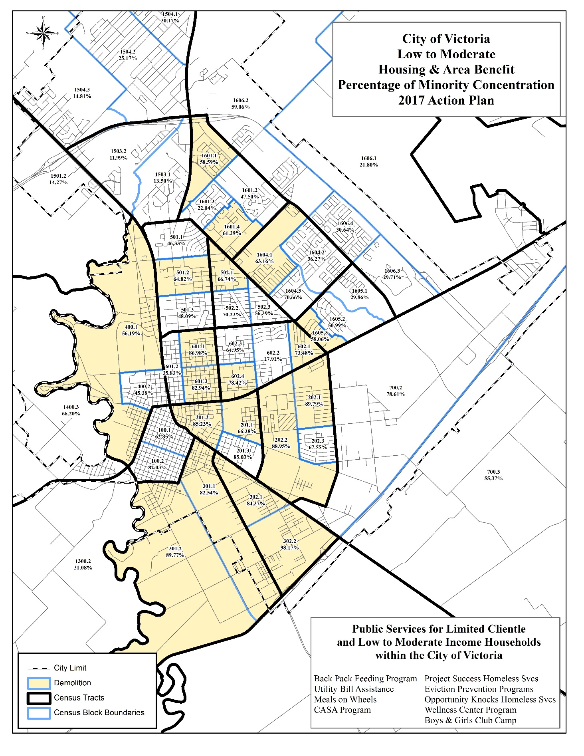

Describe the reasons for allocation priorities and any obstacles to addressing underserved needs:
The allocation priorities are based on the five goals of the Strategic Plan: affordable housing, non-housing community development, public services, public facilities and administration. CDBG funding allocations toward public services maximum is 15% of current year allocation, and administration cannot exceed 20% of the current grant funds.
Goal | Amount (% of Total CDBG)
- Administration (18.06% of PY17 entitlement funding) $92,588 (17.37%)
- Affordable Housing $15,116 (2.83%)
- Neighborhood Programs $48,283 (9.05%)
- Public Improvement activities $177,095 (33.20%)
- Public Facility activities $120,000 (22.50%)
- Public Services (*15% entitlement cap & 15% previous year PI) $80,281* (15.05%)
The primary obstacle the city faces in addressing underserved needs is funding. In recent years the reduced funding has hindered the City’s ability to meet all the needs of low-income residents. The City seeks to provide funding for as many suitable programs as possible; however, with only the current grant funding it is becoming extremely more difficult.

AP-38 Project Summary
Project Summary Information
Agency/Program Name | Amount
Administration | $92,588 $92,588
Affordable Housing | $15,116
Mortgage Assistance Program | $15,116
Neighborhood Programs | $48,283
Demolition | $48,283
Public Facilities | $120,000
Boys & Girls Club | $120,000
Public Improvements | $177,095
Other Public Facility/ Improvement (Street Lighting) | $32,095
Hopkins Neighborhood Park Trail Project | $145,000
Public Services | $80,281
Community Action Committee (utilities) | $10,000
Community Action Committee (meals) | $10,000
Faith Family Eviction Prevention | $10,000
Golden Crescent Food Bank- Back Pack | $10,000
Boys & Girls Club | $7,790
KIDZconnection | $10,000
Perpetual Help Home | $7,803
CASA | $5,000
Gulf Bend | $9,688
TOTAL | $533,363

AP-50 Geographic Distribution – 91.220(f)
Description of the geographic areas of the entitlement (including areas of low-income and minority concentration) where assistance will be directed
The City did not award projects based on a targeted geographic area, but all money will be expended within eligible areas within the City of Victoria. All the activity will be expending within the City of Victoria. The low-moderate income (LMI) area-based projects projected in the 2017-2018 Annual Action Plan program year are the Hopkins Neighborhood Park Trail Project, Street Lighting project and a Demolition program. The Hopkins Neighborhood Park is located in the 301.1 Census Block, which is a low/moderate income census block group. All activities will benefit low-moderate income persons. Funding for the Street Lighting project will be located in high traffic corridors from Navarro to Sam Houston on Rio Grande Street. The installation of approximately 39 upgraded lights and 18 new lights will promote a more suitable living environment and increase the safety, accessibility and availability of both driven and pedestrian routes located in 601.3, 201.2, 602.4, 201.1, 202.2, 602.1 and 202.1. The final LMI funding is the Demolition program that will assist nine (9) homeowners living in LMI areas to removal dilapidated, abandoned or burned structures in the low-income areas.
Geographic Distribution

Target Area | Percentage of funds
City of Victoria | 0%
Swan Crossing | 0%
Low and Moderate Income Census Block Groups | 0%
Table 4 - Geographic Distribution

Rationale for the priorities for allocating investments geographically
HUD noted last year that although the following are specific targeted areas they do not meet the definition of Target Areas for the geographic distribution percentages. The breakdowns where as follows: City of Victoria citywide is 35.25% and 64.75% in low-moderate income block. For the 2017-2018 Annual Action Plan program year, all of the public services funding is to benefit low and moderate-income persons, homeless persons, and those that are severely disabled which is the same geographic percentages shown above. Additionally within the LMI census block groups, the City plans to use 27.18% of the 2017-2018 funds to improve the Hopkins Neighborhood Park Trail Project that will benefit 2,161 persons. The low and moderate-income Census block is 301.1 and the group’s contingent with the park will include 301.2 and 302.1. Demolition funding makes up 9.05% of the funding to assist nine (9) structures located in low and moderate-income Census block groups to clear debris and/or removal of dilapidated, abandoned or burned structures. The street lighting installation project is funded to install approximately 39 upgraded lights and 18 new lights promoting a more suitable living environments by increasing the safety, accessibility and availability for driven and pedestrian routes located in Census Block Groups 601.3, 201.2, 201.1, 202.2, 602.4, 602.1 and 202.1.

Discussion
The majority of funding in the City of Victoria is designated toward projects that can be utilized by certain persons with eligible income characteristics, rather than those that live in a certain area. Area benefit programs such are the Boys & Girls Club, Hopkins Neighborhood Park Trail project and the Street Lighting projects that will receive 55.70% of the 2017-2018 funding. Homeless persons, regardless of which census block group they are currently located in are eligible for assistance. The Boys & Girls Club of Victoria Public Facility Project is the largest project funded within the City of Victoria. This project will benefit 1705 persons within the City of Victoria.

AP-55 Affordable Housing – 91.220(g)
Introduction
The Annual Action Plan must specify goals for the number of homeless, non-homeless, and special needs households supported within the program year. Table 6 shows the number of households supported through rental assistance, production of new units, rehabilitation of existing units, and acquisition of existing units.
One Year Goals for the Number of Households to be Supported
Homeless | 0
Non-Homeless (Eviction Prevention) | 32
Special Needs (elderly, severely disabled and abused neglected children) | 0
Total | 32
Table 5 - One Year Goals for Affordable Housing by Support Requirement
One Year Goals for the Number of Households Supported Through
Rental Assistance | 25
The Production of New Units | 1
Rehab of Existing Units | 0
Acquisition of Existing Units | 6
Total | 32
Table 6 - One Year Goals for Affordable Housing by Support Type
Discussion
The City plans to support through homeless services during the 2017-2018 Annual Action Plan year, 216 homeless persons with CDBG funding. Through the Opportunity Knocks program provided by Perpetual Help Home (40) homeless women job-training skills to enable them, to become a contributing member of the community. Eviction prevention assistance provided by Faith Family will assist 25 families/62 persons from eviction. KIDZconnection and Kid’s Backpack programs will serve 50 homeless junior high and 67 elementary children each. Of the supported homeless services, 25 households that will be supported through CDBG eviction prevention funding.
Currently, the Victoria Housing Authority (VHA) provides Rental Assistance to 320 households through the Victoria Housing Authority’s (VHA) Tenant Based Rental Assistance (TBRA) voucher program, which allow low-income persons to rent privately owned houses or apartments dispersed throughout the community. Additionally, the City will provide six homebuyers with down payment and closing cost assistance for their purchase of homes that helps meet our five-year goals of assisting 24 first-time homebuyers. Lastly, the Homebuyer Assistance Programs at Swan Crossing, which offers up to $20,000 of assistance ($5,000 to down payment assistance and closing cost, and a $15,000 lot) to homebuyers to purchase a new home, will be finalized this program year. Of the 55 total lots that were made available, only one is still available (and the home is currently under construction); therefore, one homebuyer will receive the New Housing Homebuyer Assistance this year.
There is 91 special needs persons receiving special needs services through the Gulf Bend Wellness Community Program Services, CASA, and Meals-on-Wheels programs. Also through Community Action Committee, 100 non-homeless households/250 persons will receive utility assistance in order to prevent service disconnection. The program is designed to make housing more affordable by ensuring access to utilities necessary for a healthy and sanitary living environment. The total special needs services are 341 persons and of that, three (3) are severely disabled households to be supported.

AP-60 Public Housing – 91.220(h)
Introduction
This section describes what actions the City of Victoria plans to take in the 2017-2018 program year to carry out the public housing goals set in the strategic plan. Below, the City of Victoria has identified the manner in which 2017-2018 Annual Action Plan will address these needs.
Actions planned during the next year to address the needs to public housing
The City of Victoria's action plans is to continue to address public housing needs by supporting the funding of 314 public housing vouchers and support an employment/job training public service program to assist households transition from public housing units to independent living at a quicker pace.
Actions to encourage public housing residents to become more involved in management and participate in homeownership
Currently the City encourages public housing residents who are at-risk homeless to participate in budget management classes though an eviction prevention program. The City currently seeks to provide this assistance to 40 persons through a grant with Perpetual Help Home during the 2017-2018 Annual Action Plan year, and 300 across the 2015-2019 Five- year plan. Additionally, the Victoria Housing Authority has a resident commissioner serving on the board and, since January 2016, residents in the Voucher program are allowed to serve. Currently the Board’s resident member participates in the Voucher program and is very active. All Public Housing residents are considered to be part of the Resident Advisory Board and annually the Housing Authority sends out a letter to residents inviting them to join the Resident Advisory Board.
If the PHA is designated as troubled, describe the manner in which financial assistance will be provided or other assistance
Not Applicable
Discussion
Although the City of Victoria does not have any plans to increase the number of public housing units during the 2017-2018 Annual Action Plan program year, it will continue to support the funding of 314 public housing vouchers. Through employment / job training public service program, the City of Victoria hopes to help household’s transition at a quicker pace from public housing units to independent living.
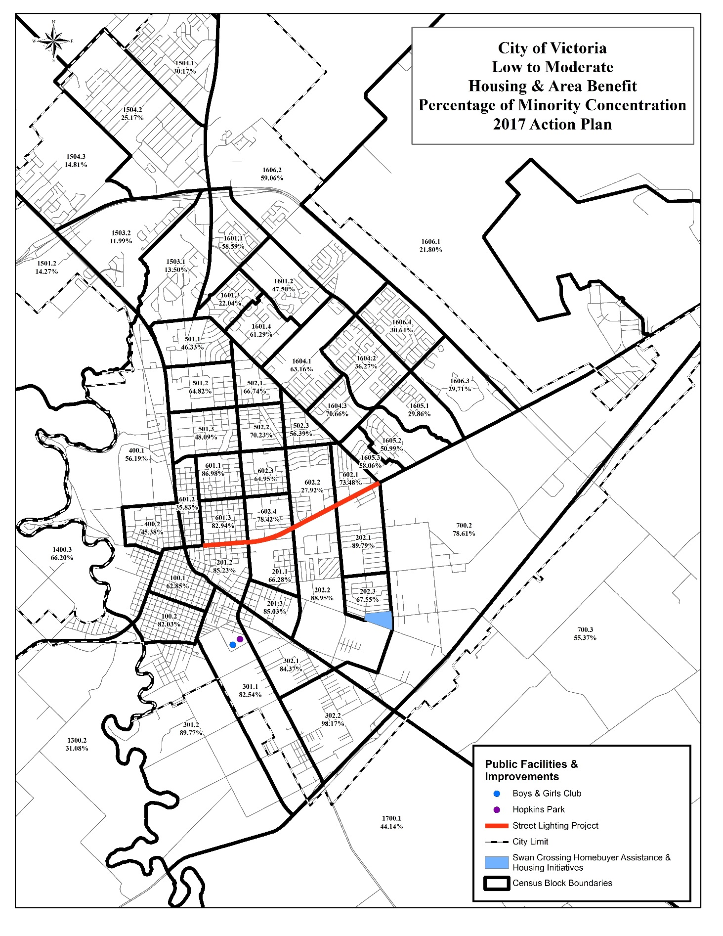

AP-65 Homeless and Other Special Needs Activities – 91.220(i)
Introduction
This section will discuss the City of Victoria’s plan during the 2016-2017 Annual Action Plan to reduce homelessness using the goals identified in the strategic plan. This section also addresses the activities related to supporting housing needs of non-homeless populations.
Describe the jurisdictions one-year goals and actions for reducing and ending homelessness including: Reaching out to homeless persons (especially unsheltered persons) and assessing their individual needs.
Consistent with the Five-Year Consolidated Plan’s Strategic Plan, the City of Victoria will pursue the goal of reducing homelessness. The City has programmed public service activities that meet the following objectives of the strategic plan:
- Provide services to the homeless that promote self-sufficiency.
- Continue to support programs within the City that offer meals, shelter facilities and/or shelter beds to the homeless.
- Increase the capacity of shelters for the homeless.
Victoria currently tries to address as many individual needs of the homeless as possible. In regards to the unsheltered homeless, their main needs are food and shelter. Many are currently provided warm meals through the local soup kitchen, Christ’s Kitchen, six days a week. There are currently 178 beds available to many different groups of homeless individuals, 98 of which are emergency housing beds, 38 transitional housing beds, 6 treatment center beds and 36 permanent supportive housing beds to aid residents in getting back to independent living. For those that are sheltered homeless, many of our shelters also provide education/ job training programs.
Addressing the emergency shelter and transitional housing needs of homeless persons
The City of Victoria relies on CDBG funds and the resources of the non-profit agencies to address the emergency shelter needs. Presently the City of Victoria has 98 emergency housing beds, 38 transitional housing beds, and 6 treatment center beds. These beds are organized to meet the needs of various groups of homeless. Currently 30 of the emergency beds are just for homeless men, while 60 are used for women, and eight (8) individual/ family emergency shelter beds. All of the 38 transitional housing beds are currently only available to women and children. Additionally, during the 2016-2017 program year Mid-Coast Family Services increased its capacity of shelters by adding 2 additional bedrooms that will serve 4 additional women and their children nightly for an additional 68 battered women annually. This should go a long way in providing safe and accessible housing to homeless persons in the City of Victoria.

Helping homeless persons (especially chronically homeless individuals and families, families with children, veterans and their families, and unaccompanied youth) make the transition to permanent housing and independent living, including shortening the period of time that individuals and families experience homelessness, facilitating access for homeless individuals and families to affordable housing units, and preventing individuals and families who were recently homeless from becoming homeless again
There are many mainstream social service agencies that provide services and programs to prevent homelessness that will be utilized in the 2017-2018 Annual Action Plan, particularly education, job training, counseling, soup kitchen, emergency water bill assistance, and life skills training, among others. Currently the City of Victoria through the Continuum of Care (CoC) has 36 permanent supportive housing beds to aid residents in getting back to independent living. 18 of these permanent housing beds are designated to chronically homeless men, nine (9) to women and children, and nine (9) to families with disabilities.
In order to shorten the amount of time that a person spends homeless there are 98 emergency shelter beds, and 38 transitional shelter beds. Many of these beds are available to any person in need of shelter; however, 30 emergency shelter beds are designated for just men. All 38 transitional beds are for women and children only. Drug and alcohol rehabilitation is offered through many of the shelters. The public service agencies also provide job training to the homeless to help those looking for employment rejoin the work force.
During the 2017-2018 Action Plan year, the City plans to provide 100 extremely low-income and low-income households with water bill assistance, as well as 25 households with eviction prevention assistance. These programs become very useful to shorten the period of homelessness and to prevent individuals and families who were recently homeless from becoming homeless again.
Helping low-income individuals and families avoid becoming homeless, especially extremely low-income individuals and families and those who are: being discharged from publicly funded institutions and systems of care (such as health care facilities, mental health facilities, foster care and other youth facilities, and corrections programs and institutions); or, receiving assistance from public or private agencies that address housing, health, social services, employment, education, or youth needs
One of the City of Victoria’s strategies for reducing homelessness is by providing programs and services for low-income individuals and families that will hopefully prevent them from becoming homeless. The Subsistence Support Services is for extremely low-income and low-income individuals to receive water utility assistance, food, and eviction prevention assistance, when possible. The City will continue to working to increase the number of affordable housing units in the City for low-income individuals.
Many non-profit service providers in the city also provide assistance to low-income and very low-income households such as Golden Crescent Habitat for Humanity. Habitat builds affordable housing for individuals and/or families who earn between 35% to 60% HAMFI. Habitat for Humanity is now constructing homes in a subdivision that is not within a CDBG-eligible Census block group and no eligible Habitat location is expected to be available within the remaining years of the current CPS. To continue to address affordable housing-related CPS goals, this amendment will allocate additional funds to the Mortgage Assistance Program.

The Salvation Army provides Stepping Stone, a drug and alcohol rehabilitation program that can be used by individuals to help them become drug free, and prepare them for re-entry into society, which will continue to operate, but were unable to apply for funding during the 2017-2018 program year. The Gulf Bend Wellness Community is an Intermediate Care Facility with the primary goal being to move people with intellectual and developmental disabilities toward a higher level of independence.
Discharge planning and discharge follow up occurs for all individuals leaving a State Hospital/School returning to the local service area. This ensures people have services lined up upon their return such as doctor services and medication refills. Programs at the Wellness Community ensure doctor appointments are scheduled and all appointments are attended. They also schedule daily fitness classed and teach healthy eating classes and offer smoking cessation classes. This will help the severely disabled to reduce medical visits with a healthier living style and transitional housing for a term of 18-24 months. Transitional housing offers short term living that incorporates living/life skills to include job search and permanent housing. Currently when a person returns from a mental and physical health institution the intention would be for them go into a permanent supportive housing unit. However, there are not enough units currently to allow for that.
One year goals for the number of households to be provided housing through Housing Opportunities for Persons With AIDS (HOPWA)
The City of Victoria does not receive Housing Opportunities for Persons With AIDS (HOPWA) funding. This goal is met through the County of Victoria Special Services, the local provider who has reported there are 103 individuals living with HIV/AIDS in Victoria accordingly to the 2015 report published by the Texas Department of State Health Services.
The City of Victoria tries to help as many homeless as possible each year. During the 2017-2018 Annual Action Plan Year, the City will work to reduce the number of homeless by providing services to the homeless and those at-risk of becoming homeless that promote self-sufficiency; continue to support programs within the City that offer meals, shelter facilities and/or shelter beds to the homeless; and increase the capacity of shelters for the homeless. Currently the City has a large variety of different beds to meet the varying needs of groups of homeless persons. However, the quantity of beds in the City is far too limited, as all of the shelters are currently operating at capacity.

AP-75 Barriers to affordable housing – 91.220(j)
Introduction:
In the City of Victoria, there is a great need for affordable housing to prevent households from becoming cost burdened by housing costs. HUD requires jurisdictions that receive federal funds to commit to taking actions to affirmatively further fair housing. The City of Victoria has identified six barriers to affordable housing that are outlined in the City’s Analysis of Impediments. These impediments are neighborhood deterioration, inadequate supply of low cost homes, inability to obtain safe rental housing, need for housing and services for the homeless and minimum lot size requirements.
Actions it planned to remove or ameliorate the negative effects of public policies that serve as barriers to affordable housing such as land use controls, tax policies affecting land, zoning ordinances, building codes, fees and charges, growth limitations, and policies affecting the return on residential investment
These barriers are a big issue to the City of Victoria, and correcting them is vital to ensure equal access to housing for persons at like income levels. Currently the City of Victoria does have strategies in place to address these barriers to affordable housing.
- Neighborhood Deterioration- Neighborhood Deterioration- Efforts to sustain and revitalize neighborhoods will be carried out through the demolition program. During the 2017-2018 Annual Action Plan year the city plans to demolish nine (9) homes that have deteriorated. In PY 2017 a Street Lighting program will involve installing 18 new street lights and 39 upgrades in Rio Grande and upgrade of Hopkins Park located in a low-moderate income area.
- Inadequate Supply of Low Cost Homes- The Mortgage Assistance Program will be carried forward by providing down payment and closing cost assistance to (6) first time homebuyers. The New Housing Initiative and Homebuyer Assistance Programs at Swan Crossing offers up to $20,000 of assistance ($5,000 to down payment assistance and closing cost, and a $15,000 lot) to homebuyers to purchase a new home. Only one (1) homebuyer will receive New Housing Homebuyer Assistance and in saying that; it will complete the 55 new homes built at Swan Crossing subdivision. Discussion will continue with Habitat for Humanity in a new "Brush Up" rehabilitation program.
- Inability to Obtain Safe Rental Housing- Rental housing assistance provided through the Eviction Prevention Programs that can provide housing assistance for eligible renters on the verge of eviction. The program is funded to provide 25 families/62 persons rental assistance
- Need for Home Ownership Education- Prospective homebuyers currently participating in the New Housing Homebuyer Assistance Program are provided home ownership education before purchase. This service is being provided through an on-line service for all income-eligible homebuyers meet the home ownership-training requirement. Homebuyers requiring education or classes will be directed to other area resources as necessary to meet the new HUD requirements concerning licensing of instructors. Homebuyer classes are not anticipated to be held during the 2017-2018 program year due to the completion of the Swan Crossing new housing subdivision.
- Need for Housing and Services for the Homeless- The City works with the Victoria Area Homeless Coalition to address the needs of the homeless. Through the Public Service Activities, the Water bill assistance and eviction prevention assistance are available to aid in the prevention of homelessness through subsidence support. A support program to provide services to those with severe disability issues so they learn how to maintain normal living habits, and not revert to poor choices and homelessness. A job-training service for homeless women to enable them to be responsible citizens within the community. The city has also funded 2 programs to assist homeless elementary and middle students at Victoria Independent School District (VISD). Mid-Coast Family Services Women’s Crisis Center offers services for battered men and women and emergency shelter for homeless women and Faith Family is reopening a shelter for women and children during the 4th quarter 2017. Additional information will be included in the CAPER.
- Insufficient Public Minimum Lot Size Requirements- Minimum lot size is a subdivision-platting requirement established by City Code. No CDBG programs address this barrier; however, staff recognizes the potential hardship caused by this requirement. To alleviate this we have created new lot categories to promote infill. The “cottage lot” category only requires minimum size of 4,000 sf. provided certain conditions be met.
Discussion:
The City of Victoria has plans in place during the 2017-2018 Annual Action Program Year to address many of the barriers to affordable housing. Although these programs will not eliminate the barriers to affordable housing, they will make more homes affordable, and accessible to low and moderate income families. The programs address neighborhood deterioration and provide eviction assistance to low-income persons that prevent a family from going into homelessness. Utility assistance also assists in preventing homelessness and health issues that stem from loss of utilities. The Gulf Bend Wellness Center project offers assistance in housing for the severely disabled adults to decrease the homelessness of person not mentally and/or physically unstable to cope with their housing needs. The two (2) programs for homeless students; the Kid’s Backpack Program and the Project Success helps students not go hungry on the weekends or holidays during the school year and also provides assistance through a Project Success assistant ensuring they receive all support needed to be successful as a student. Perpetual Help Home and Mid-Coast Family Services are both shelters for homeless women all seeking a safe and decent living environment.

AP-85 Other Actions – 91.220(k)
Introduction:
This section of the Annual Action Plan describes the City of Victoria’s planned actions to carry out the following strategies outlined in the Strategic Plan:
- Address obstacles to meet underserved needs
- Foster and maintain affordable housing
- Evaluate and reduce lead-based paint hazards
- Reduce the number of poverty-level families
- Develop institutional structure
- Enhance Coordination
Actions planned to address obstacles to meeting underserved needs
As a small entitlement City, there are extremely limited resources available to meet all the needs. The City will address the priorities that were identified in the 2015-2019 Consolidated Plan and Strategy. The majority of funding has been allocated to projects and activities in high priority categories. The following obstacles to meeting underserved needs were identified in the Consolidated Plan and Strategy:
- Ongoing cutbacks to federal and state resources are further eroding public service agencies capacity to meet the needs for affordable housing and other community development assistance needs.
- Victoria is less than 1 percentage point above the statewide percentage of households living in poverty than the State. Approximately 14.3% of households/families in the City are living below the federal poverty line, compared with 13.4% statewide.
- Educational attainment is a significant contributing factor to poverty rates. As shown in the percentage of persons that have a bachelor’s degree or higher is 19.2% in Victoria, Texas, which is significantly lower when compared to the statewide percentage of 26.7%.
The 2015 America FactFinder census numbers shown above the City of Victoria hopes to mitigate many of these issues by providing funding to programs with the goal of helping citizens in poverty with job training. The City of Victoria currently does not have any programs to bring people out of poverty; however, there are programs in place to aid families that are in poverty from becoming cost burdened and will alleviate some of the cost burden through the assistance offered through the eviction prevention and water utility assistance programs. There are also programs that aid at-risk homeless schoolchildren with weekend food subsidence and additional counseling assistance to improve their grades and attendance.
Actions planned to foster and maintain affordable housing
The City plans to help foster affordable housing through down payment and closing cost assistance programs. New Housing Initiatives provides affordable housing in the Swan Crossing Subdivision and Mortgage Assistance Program is citywide for low-income homebuyers. The last of 55 homes located in Swan Crossing has been sold but it is very likely to be completed in the 2017-2018 program year. The city will continue to use demolition funds to help improve the sustainability in targeted neighborhoods. Another non-profit housing provider in the City of Victoria provides assistance to low-income and very low-income households is Habitat for Humanity, although the new subdivision they are currently building in is not located in a low-income eligible block group. Habitat does provide affordable housing for individuals and/or families who earn between 35% to 60% of the Housing Area Median Family Income (HAMFI). To accomplish affordability and not be cost-burdened, Habitat provides mortgages to low-moderate income homeowners interest-free; by leveraging additional grant funding. Habitat for Humanity’s current neighborhood is not an eligible census block group and Habitat will not be completing the new homes in its Koininea Subdivision until after the 2019.
Actions planned to reduce lead-based paint hazards
In 2001, HUD implemented regulations that required cities to address lead based paint hazards in their housing programs. From these regulations the cost to rehabilitate one house affected by lead based paint would cost a minimum of $4,000 more per unit than one without a lead based paint hazard. The City recognizes a need for reducing the quantity of homes with lead based paint and will continue to support rehabilitation activities.
However, the rising costs to address lead paint hazards are not feasible for the City to support in the 2017-2018 Annual Action Plan program year. Presently, the Texas Childhood Lead Poisoning Prevention Program administered by the Texas Department of State Health Services, annually tests children under the age of six for elevated blood lead levels.
Actions planned to reduce the number of poverty-level families
Currently there are no policies to reduce the number of households with incomes below the poverty level, but there is a program; Opportunity Knocks at Perpetual Help Homes’ Center of Peace to help reduce the number of women living in poverty through job training. This program offers job skills, education and employment to women who are homeless living in the transitional shelter. The City is currently providing the maximum 15% of its funding towards Public Service Agencies, and 55.70% of the budget is being directed towards Public Facility and Public Improvement projects. With the funding provided towards public services and public facilities the City is aiming to improve the quality of life of those persons currently living in poverty.

Actions planned to develop institutional structure
The City of Victoria Development Services Department oversees the development of the Consolidated Plan and is responsible for the oversight of activities funded through the CDBG Program. Development Services assures the eligibility of proposed projects, assists in accountability review, and meets financial and oversight requirements of HUD. The activities undertaken with CDBG funds involve other city offices such as Code Enforcement, Environmental Services, Parks & Recreation and Public Works. The City will continue to use its existing institutional structure during the 2017-2018 Annual Action Plan Year to ensure CDBG funds are allocated to the proper organizations.
Actions planned to enhance coordination between public and private housing and social service agencies
The City of Victoria will continue to coordinate with agencies during monthly meetings to address the needs of service agencies. The City promotes all opportunities to facilitate quarterly meetings to streamline information and increase communication and coordination.
Discussion
The City of Victoria will take many steps during the 2017-2018 Annual Action Plan Program Year to enhance services to low and moderate income residents by identifying and reducing obstacles and barriers to addressing the needs cost effectively and efficiently within the Federal regulations. The ease of communication between City staff, and the public and sub-recipients of CDBG funding will allow for funding to go to the appropriate programs.

AP-90 Program Specific Requirements – 91.220(l)(1,2,4)
Introduction:
The following section addresses the program-specific requirements for the Annual Action Plan
Community Development Block Grant Program (CDBG)
Reference 24 CFR 91.220(l)(1)
Projects planned with all CDBG funds expected to be available during the year are identified in the Projects Table. The following identifies program income that is available for use that is included in projects to be carried out.
1. The total amount of program income that will have been received before  the start of the next program year and that has not yet been reprogrammed | $0.00
2. The amount of proceeds from section 108 loan guarantees that will be  used during the year to address the priority needs and specific objectives  identified in the grantee's strategic plan | $0
3. The amount of surplus funds from urban renewal settlements: | $0
4. The amount of any grant funds returned to the line of credit for which the planned use has not been included in a prior statement or plan. | $0
5. The amount of income from float-funded activities | $0
Total Program Income | $00.00

Other CDBG Requirements
1. The amount of urgent need activities | 0
2. The estimated percentage of CDBG funds that will be used for activities that benefit  persons of low and moderate income | 80%

Discussion
There is no program income which has been included in the 2017-2018 Action Plan for the City of Victoria. The Program income has been receipted in IDIS but has not been programed. As program income is received the Action Plan will be amended accordingly based on the requirements in the Citizen Participation Plan.

Certification Appendices

Appendix A - Certifications
In accordance with the applicable statutes and the regulations governing the consolidated plan regulations,
the jurisdiction certifies that:

Affirmatively Further Fair Housing --The jurisdiction will affirmatively further fair housing.

Uniform Relocation Act and Anti-displacement and Relocation Plan -- It will comply with the
acquisition and relocation requirements of the Uniform Relocation Assistance and Real Property
Acquisition Policies Act of 1970, as amended, (42 U.S.C. 4601-4655) and implementing regulations at 49
CFR Part 24. It has in effect and is following a residential anti-displacement and relocation assistance
plan required under 24 CFR Part 42 in connection with any activity assisted with funding under the
Community Development Block Grant or HOME programs.

Anti-Lobbying -- To the best of the jurisdiction's knowledge and belief:

1. No Federal appropriated funds have been paid or will be paid, by or on behalf of it, to any person for influencing or attempting to influence an officer or employee of any agency, a Member of Congress, an officer or employee of Congress, or an employee of a Member of Congress in connection with the awarding of any Federal contract, the making of any Federal grant, the making of any Federal loan, the entering into of any cooperative agreement, and the extension, continuation, renewal, amendment, or modification of any Federal contract, grant, loan, or cooperative agreement;

2. If any funds other than Federal appropriated funds have been paid or will be paid to any person for influencing or attempting to influence an officer or employee of any agency, a Member of Congress, an officer or employee of Congress, or an employee of a Member of Congress in connection with this Federal contract, grant, loan, or cooperative agreement, it will complete and submit Standard Form-LLL, "Disclosure Form to Report Lobbying," in accordance with its instructions; and

3. It will require that the language of paragraph 1 and 2 of this anti-lobbying certification be included in the award documents for all subawards at all tiers (including subcontracts, subgrants, and contracts under grants, loans, and cooperative agreements) and that all subrecipients shall certify and disclose accordingly.

Authority of Jurisdiction --The consolidated plan is authorized under State and local law (as applicable)
and the jurisdiction possesses the legal authority to carry out the programs for which it is seeking funding,
in accordance with applicable HUD regulations.

Consistency with plan --The housing activities to be undertaken with Community Development Block
Grant, HOME, Emergency Solutions Grant, and Housing Opportunities for Persons With AIDS funds are
consistent with the strategic plan in the jurisdiction’s consolidated plan.

Section 3 -- It will comply with Section 3 of the Housing and Urban Development Act of 1968, and implementing regulations at 24 CFR Part 135.

_________________________________ _______________
Signature/Authorized Official Date
City Manager
Specific CDBG Certifications

The Entitlement Community certifies that:

Citizen Participation -- The City’s Citizen Participation Plan is in full compliance and satisfies the requirements of 24 CFR 91.105.

Community Development Plan -- Its consolidated plan identifies community development and housing
needs and specifies both short-term and long-term community development objectives that that have been
developed in accordance with the primary objective of the CDBG program (i.e., the development of
viable urban communities, by providing decent housing and expanding economic opportunities, primarily
for persons of low and moderate income) and requirements of 24 CFR Parts 91 and 570.

Following a Plan -- It is following a current consolidated plan that has been approved by HUD.

Use of Funds -- It has complied with the following criteria:

1. Maximum Feasible Priority. With respect to activities expected to be assisted with CDBG funds, it certifies that it has developed its Action Plan so as to give maximum feasible priority to activities which benefit low and moderate income families or aid in the prevention or elimination of slums or blight. The Action Plan may also include activities which the grantee certifies are designed to meet other community development needs having a particular urgency because existing conditions pose a serious and immediate threat to the health or welfare of the community, and other financial resources are not available;

2. Overall Benefit. The aggregate use of CDBG funds including Section 108 guaranteed loans during program year(s) 2017, (a period specified by the grantee consisting of one, two, or three specific consecutive program years), shall principally benefit persons of low and moderate income in a manner that ensures that at least 70 percent of the amount is expended for activities that benefit such persons during the designated period;

3. Special Assessments. It will not attempt to recover any capital costs of public improvements assisted with CDBG funds including Section 108 loan guaranteed funds by assessing any amount against properties owned and occupied by persons of low and moderate income, including any fee charged or assessment made as a condition of obtaining access to such public improvements.

However, if CDBG funds are used to pay the proportion of a fee or assessment that relates to the capital costs of public improvements (assisted in part with CDBG funds) financed from other revenue sources, an assessment or charge may be made against the property with respect to the public improvements financed by a source other than CDBG funds.

In addition, in the case of properties owned and occupied by moderate-income (not low-income)
families, an assessment or charge may be made against the property for public improvements
financed by a source other than CDBG funds if the jurisdiction certifies that it lacks CDBG funds
to cover the assessment.

Excessive Force -- It has been adopted and is enforcing:

1. A policy prohibiting the use of excessive force by law enforcement agencies within its jurisdiction against any individuals engaged in non-violent civil rights demonstrations; and

2. A policy of enforcing applicable State and local laws against physically barring entrance to or exit from a facility or location which is the subject of such non-violent civil rights demonstrations within its jurisdiction;

Compliance with Anti-discrimination laws -- The grant will be conducted and administered in
conformity with title VI of the Civil Rights Act of 1964 (42 U.S.C. 2000d) and the Fair Housing Act (42
U.S.C. 3601-3619) and implementing regulations.

Lead-Based Paint -- Its activities concerning lead-based paint will comply with the requirements of 24
CFR Part 35, Subparts A, B, J, K and R.

Compliance with Laws -- It will comply with applicable laws.

Signature/Authorized Official Date
City Manager

Appendix to Certifications
INSTRUCTIONS CONCERNING LOBBYING AND DRUG-FREE WORKPLACE REQUIREMENTS:

A. Lobbying Certification

This certification is a material representation of fact upon which reliance was placed when this transaction was made or entered into. Submission of this certification is a prerequisite for making or entering into this transaction imposed by section 1352, title 31, U.S. Code. Any person who fails to file the required certification shall be subject to a civil penalty of not less than $10,000 and not more than $100,000 for each such failure.

________________________ _____________
Signature/Authorized Official Date
City Manager

